Programming Project

Contents

Analysis 3

▮ Introduction 3

▮ Computational Approach 3

▮ Abstraction 3

▮ Decomposition 3

▮ Pattern recognition and design 4

▮ Algorithmic design 4

▮ Why use a computer? 4

▮ Stakeholders 5

▮ Players 5

▮ Myself 5

▮ Asset creators 6

▮ Teacher 6

▮ Research 6

▮ Existing solutions 6

▮ Essential features 7

▮ Limitations 7

▮ Solution specification 8

▮ Requirements 8

▮ Success criteria 9

▮ Menu 9

▮ AI/Computer controlled enemies / allies 9

▮ Save game handler 9

▮ Gameplay 9

Design 9

▮ Decomposition tree 9

▮ Decomposed elements 10

▮ Data handling 10

▮ Pausing 11

▮ Map generation 11

▮ Player handling 12

▮ Structure 12

▮ Data Handling 13

▮ Pausing 13

▮ Map Generation 14

▮ Player handling 15

▮ Key classes 15

▮ Data Handling 15

▮ Pausing 15

▮ Map Generation 15

▮ Player Handling 16

▮ Post-development Data 17

Implementation 17

▮ Window Setup 17

▮ Pause Function 19

▮ Player Movement and Handling 22

▮ Map Generation 26

▮ Tiled Map Creation 35

▮ Item Generation 37

▮ Collisions 41

▮ Room Exit Collisions 41

▮ Item Collisions 45

▮ Updating player model 46

▮ Inventory 48

▮ Enemies 53

▮ Intermission 59

▮ Graphics and sound 59

▮ Complete saving and loading 59

▮Enemy attacks 59

▮Bosses / End state 59

▮Status bars 60

▮ Inventory saving and loading 60

▮ Enemy attacks 63

▮ Item classification 67

▮ Text boxes 74

▮ Bosses 79

Testing for Evaluation 80

▮ Self-testing 80

▮ External-testing 81

Evaluation 82

▮ Success 82

▮ Menu 82

▮ AI/Computer controlled enemies / allies 82

▮ Save game handler 82

▮ Gameplay 83

▮ Maintenance 84

▮ Further development 84

# Analysis

## ▮ Introduction

The problem I want to solve is the sporadic boredom that most young people experience on a day-to-day basis, which short, hyper-casual games alleviate. Most youths don’t carry around entire board games or card games for when they feel stressed, but they do however carry their phone or are within the near vicinity of a computer. This, combined with the need and desire to escape reality for a few moments, prompted me to create my semi-short, hyper-casual game, ‘GAME NAME’, aimed at providing both a quick or prolonged experience so the user can feel less stressed and relax, something which is very necessary in today’s tense, cut-throat world.

My original idea for my game involved the player choosing a planet, then surviving and evolving as a single-celled organism until they have colonised the planet from which they would then colonise another planet, creating a looped gameplay experience. This idea was very ambitious and far too complex given my timeframe and development ability (after all I am only 1 A-Level student), and I was not very passionate about the idea. Instead, I have decided to go for another idea. Similarly, to my original idea, the player will choose a random planet, and will then have to fight their way through a dungeon on said planet. The dungeon will be influenced by the planet chosen such as appearance, loot, enemies, and effects. I believe that this idea is much more attainable, and I am excited to work on it.

## ▮ Computational Approach

### ▮ Abstraction

My game will heavily utilise abstraction. A complex, layered dungeon is extremely complicated. It is impossible to re-create every aspect of one. I will remove both small features of a dungeon, such as ambient sounds and weather, and large features, such as floors that the user is not currently on. This means that my problem is more achievable, the user is not flooded with unnecessary information, and the performance of the game should be better as the machine is not having to perform useless operations. I have abstracted small features, such as the soil pH and time of day, as they are negligible and would provide unnecessary complexity to my solution. Abstracting features like this also allows for maximum code efficiency in both speed and size.

### ▮ Decomposition

Decomposition is very necessary for my problem. Tackling a problem this big all at once would be impossible and would confuse me and that would lead to a faulty, bug-filled program. I will break the problem down into many small, manageable problems, such as the following.

#### ▮ dungeon generation

Generating the layout and visuals of each dungeon is vital. This ensures each dungeon is not only possible to complete (i.e. no doorways behind walls), but also reflects the planet it is on in terms of loot, layout, appearance and enemies. If, for example, the staircase to the floor below is blocked by a procedurally generated wall, the player has no choice but to prematurely end their game, and this would lead to a poor player experience. This goes for all essential interactions such as those with doorways, staircases, merchants, and boss rooms; decomposing the dungeon generation is therefore essential in ensuring that every stage of the game is not only possible but enjoyable.

#### ▮ Status bars

Once the pre-game phase has been completed, your warrior will have several statistics that will be presented to you via status bars, such as health, hunger, stamina, thirst etc. This allows players to gain an understanding of their warrior’s current state and then make informed decisions about what to do next, such as focusing on healing up or if they are okay to progress to the next floor. These statistics will be pivotal to my solution and will be complex and therefore must be decomposed.

### ▮ Pattern recognition and design

Patterns form the foundation of my game. In nature and life, there are a lot of patterns which I can reflect in my game. I will use iteration as a pattern to create many objects such as atmospheres and planet composition using an object-orientated approach. Other organisms will also utilise patterns, such as their movement and behaviour. Using a computational approach allows me to generate many of these organisms, each with their attributes. Without a computational approach, this would be very cumbersome and time-consuming, therefore boring the end-user.

Patterns form the foundation of my game. Each dungeon will be generated in a similar way so I can use a pattern to generate each dungeon floor for me. I will use iteration as a pattern to create many objects such as rooms, enemies, planets and items using an object-orientated approach. Other enemies will also utilise patterns, such as their movement and behaviour. Using a computational approach allows me to generate many of these enemies, each with their attributes. Without a computational approach, this would be very cumbersome and time-consuming, therefore boring the end-user.

### ▮ Algorithmic design

My program will be object orientated. This means that I will easily be able to create the objects that I will use in my problem. Instead of creating every dungeon floor, one by one, and assigning them individual attributes, I can create several room objects and then assign them to a dungeon floor, so all the work is done for me. The same principle applies to other objects in my game, such as other organisms when playing. This is only possible using a computational approach, as many of the same objects will use the same patterns and attributes.

### ▮ Why use a computer?

The physical approach to my problem would be very difficult. As opposed to a single-player game with AI elements, a non-computational approach to my problem would be completely single-player, having to play both the roles of the player and the enemies. This is not only boring but also potentially stressful; the opposite of what I am trying to achieve. A non-computational approach would be resource and time intensive. The process of generating the dungeons and computing the enemy responses would be less immersive for the user and would therefore ruin the stress-relieving aspect.

At the start of the design process, I will go through and decompose the problem into several modules.

## ▮ Stakeholders

### ▮ Players

#### ▮ Solo

These players do not like to compare themselves to other players and prefer playing at their own pace, when they want to and how they want to. They will have an interest in my project as they will be able to leisurely pick up and play the game, then set it back down whenever they feel or need to. There is no online element, meaning they do not need to worry about how they're performing compared to others and can, therefore, relax whilst playing my game, not tense up.

#### ▮ Casual

Players like this will be more interested in my game as a means of entertainment rather than a form of retreat or education and will find joy in aspects such as boss fights. These players will be both male and female of varying ages. Casual players will most likely play this game when they have a bit of free time and therefore my game must be easy to pick up and put down. I will reflect this need with a pause function, automatic saving and loading upon launch.

#### ▮ Space fans

Players of this type will be interested in my game as they enjoy the space element of it. While my game is not primarily based on space, players will be able to briefly explore different galaxies and gain an insight to some of the types of climates different planets exhibit and how this will influence the dungeons and enemies that reside there, something which may be refreshing and interesting to see.

#### ▮ RPG fans

RPG fans could be interested in my project as it provides a different view of the typical dungeon explorer game as the planet you choose affects the dungeon you play. It will also have some pleasing, pixel-art, fantasy-like environments that could relax and ease those who enjoy fantasy. These fans will most likely be males between the age of 15-26 and therefore I will make sure the environments I project in my game are not too similar to real life.

#### ▮ Pixel-art fans

Players that enjoy the simple, retro, pixel-art style will enjoy my game as it is primarily based on pixel-art. The use of pixel-art will calm these types of players and allow them to relax as they enjoy my program. These players will most likely be older, 18 - 28, and enjoy pixel-art as nostalgia to 8-bit like games they played in their childhood. Due to this, I will use pixel-based art and fonts wherever I can in my games as this not only gives these fans a sense of their youth but is also simple for younger players to understand.

#### ▮ Progression-based Players

Players who enjoy progression would very much enjoy my game as you can either continuously progress through a dungeon or complete a dungeon and move on to another dungeon (these will be 2 separate game modes). Both these modes can provide progression-based players with a great sense of satisfaction. These players are most probably going to be males between the ages of 16 and 25 years old. Because of this, I will try to make completing dungeons as appealing to males as possible by including explosions and other special effects.

### ▮ Myself

This project will not only provide myself with entertainment, both playing the final product and coding it, but it will also allow me to hopefully obtain a great grade in computer science, and therefore will affect my future choices in life. I am a massive stakeholder in this project.

### ▮ Asset creators

Any creators that I will purchase assets from for use in this project are also stakeholders. If this project were to be published, they would require credit and the proper copyright laws must be followed.

### ▮ Teacher

My teacher will be interested in my project as they would like for myself to get the best grades, both for my success and for themselves, as my grades reflect on my teacher’s ability to teach.

## ▮ Research

### ▮ Existing solutions

#### ▮ Minecraft dungeons

Made by Mojang and Double Eleven, this game is quite similar to my own. You can customise a warrior and explore many intricate dungeons.

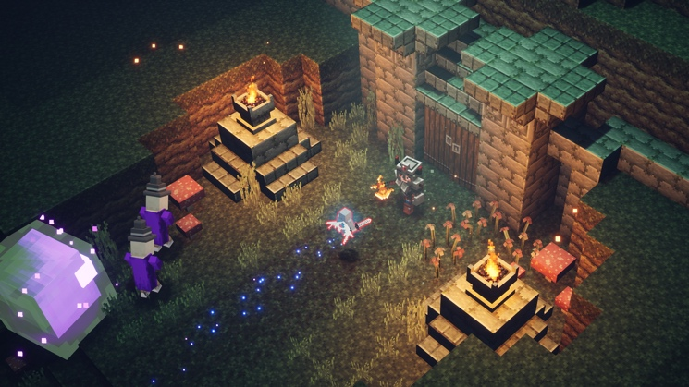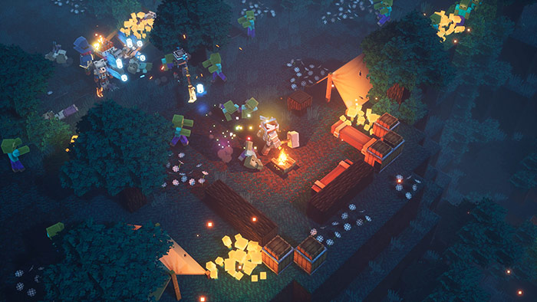

##### ▮ Similar aspects

My game will have the same exploration aspect of Minecraft Dungeon as well as the interactivity with enemies. It will, however, not be 3D and will only be 2D as I will be using pixel-art designs. Minecraft Dungeons shows that, for my game to be interesting, there must be plenty of different armour and weapons available for the player to choose from.

##### ▮ Dissimilar aspects

Unlike my game, Minecraft Dungeons does have online aspects, such as multiplayer. I will not be introducing any form of multiplayer, for complexity reasons and reasons stated in my solo player stakeholder section. Minecraft Dungeons is open world whereas my game will not be. The player will be confined to pre-generated rooms.

#### ▮ Adventure Time: Explore the dungeon because I don’t know!

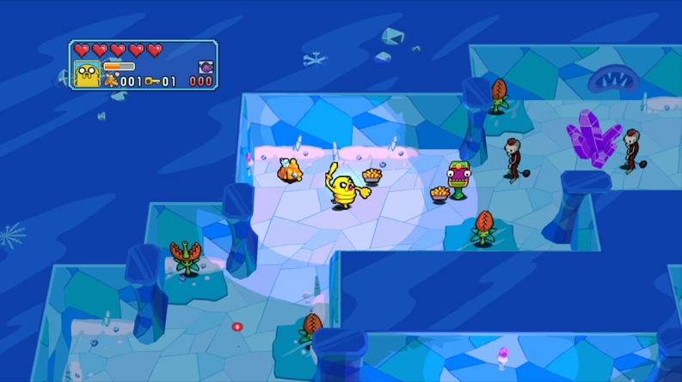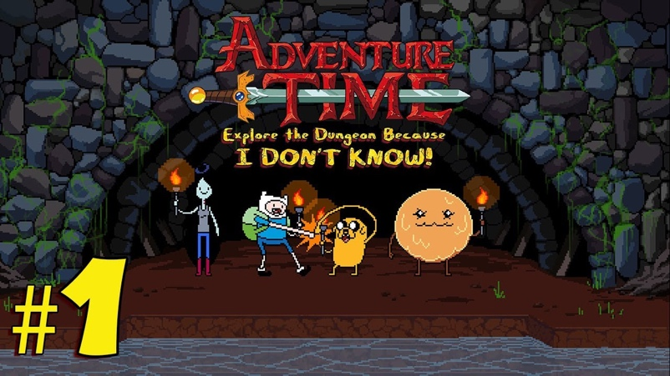Developed by WayForward, this game is also very similar to my own. You can explore themed dungeons (albeit from the Adventure Time universe, not a foreign planet) and it even incorporates a pixel art style.

##### ▮ Similar aspects

Like my game, you explore dungeons, fight enemies and trade with vendors. Explore The Dungeon Because I Don’t Know also uses a pixel art style and I think it is implemented very successfully.

##### ▮ Dissimilar aspects

This game is not room based and is instead maze-based; however, my rooms will form a sort of maze so this could be considered a similar aspect.

### ▮ Essential features

These features are must-haves for my game. The ability to save the game-state is essential, as if the player loses a severe amount of progress, they will lose interest almost immediately. If my program cannot be saved it will not be functional. My game must also be able to load saved data without corruption of the saved data file.

To engage the end-user, there must be some form of risk-reward in my game. This is essential in ensuring that the user does not grow tired of the game. Implementing several risk aspects, such as reducing stats and death, and several reward aspects, such as increased stats and cosmetic improvements, will be essential for my game.

To avoid the game becoming boring and monotonous, the levels must increase in difficulty and therefore the skill required to complete each level will increase.

Ideally, my solution will be as bug-free as possible. This would be achieved with a dedicated programming team. Unfortunately, I do not have a team as this project is solely my work, therefore is it essential I implement some procedure to deal with game-breaking bugs and crashes which can enable me to fix and examine bugs.

### ▮ Limitations

My solution has several limitations. I am only an A-Level student, not professional programming with a professional programming team or a designated office space. Much of my project will be programmed outside of school as administration and permission systems prevent me from installing the required libraries for my project, and suppose I could install the required libraries, the COVID-19 pandemic has prevented any school computer access, which has been for the better. This game will not be as large and complex as I would hope. Ideally, I would have a team of sound designers, graphic designers, project managers and programmers. Unfortunately, I must play all these roles myself which means they will all be done to a lower standard. If I were a professional programmer and was part of a team, I would introduce an option multiplayer mode, where you can team up with other dungeon explorers and make your way through the generated dungeons. I would also implement some in-depth customisation of characters, enemies, weapons and dungeons; as well as a dungeon creator for players to make their own dungeons. I would also be able to debug my program further and respond to user requests.

My game will only be playable on desktop computers or laptops, no mobile phones; this will limit my user-base and the nature of my game. Rather than being a “pick up and play” game that you could use on your phone as you commute, it will be a casual game that one can play with access to a desktop.

## ▮ Solution specification

### ▮ Requirements

#### ▮ Hardware

My project is not graphically intense. It contains no 3D models, lighting, ray-casting or other GPU-heavy processes and therefore hardware requirements are very low-end. This means my user-base is very wide and will be accessible to all users with a personal computer. If I had was part of a development team, we could also investigate making a mobile version.

#### ▮ Software

The end-user may need to have certain software installed depending on how I distribute my project. I can choose to distribute my program in 2 ways:

##### ▮ Python file

Firstly, I could distribute my program as a compressed zipped version of the folder that it is currently located in. This would mean, to play the game, the user would have to run the file "main.py", providing they have the latest version of Python installed. This has its pros and cons. Using this method, it would be quicker and easier for me to distribute newer versions of my project, however, it relies too much on the end user's knowledge and is not very professional.

##### ▮ Compiled binaries

An alternative method would be compiling my program into executable files for different operating systems. I would create 3 files, a .exe file for Windows systems, a .dmg file for Mac systems and a.DOT for Linux systems. To do this I will need to use several different pieces of software.

To convert my .py file to their respective files, I would use “PyInstaller”, a Python Package that is included in the Python Package Index.

I could go further and turn the Windows .exe file into an installable Windows .msi file. This would install all the required folders and assets to the user’s computer for my .exe file to be able to access. I will use “EXE to MSI” to achieve this.

I could convert the .dmg file generated into a .pkg for distribution on Macs.

This approach also has pros and cons; this is a much more commercially acceptable and recognised way of distributing software but means more effort and software requirements on my part and I am trusting that the software I am using to compile my project is bug-free, as it is out of my hands.

## ▮ Success criteria

### ▮ Menu

The user should be able to:

* Create a new save of the game
* Continue an existing save
* View current save files
* Delete save files
* View and change any game settings

### ▮ AI/Computer controlled enemies / allies

* Physically interact with the player
* Be able to die
* Be able to kill the player (enemies)
* Be able to help the player (allies)

### ▮ Save game handler

To correctly save and load the game, the handler must:

* ~~Retrieve all variables from a JSON or CSV file~~
  + Retrieve all variables from a CSV or pickle file
* Load all retrieved variables and values without corruption

### ▮ Gameplay

#### ▮ GUI

* Always display basic statistics in a clean, understandable way at the bottom of the window

#### ▮ Pre-game

* Display several planets in a friendly way
* When a planet is clicked on, show its details including its name and its climate
* Allow the player to select a planet when they have found one, they like
* Choose character appearance

#### ▮ In-game

* Allow the player to freely move around a fixed room and enter new rooms
* Allow the player to interact with the AI enemies and allies
* Allow the player to advance to a different floor
* Be influenced by the planet’s climate

# Design

## ▮ Decomposition tree

Below is a diagram showing how I will decompose my solution:

I will decompose my solution into several parts, the most notable being:

* Data Handling
* Pausing
* Map Generation
* Player Handling

## ▮ Decomposed elements

### ▮ Data handling

This data handling portion of my solution will be used to save the game-state. It will also handle loading and deletion of saves. This section is separate from the gameplay section of my solution, as it doesn’t rely on any of the same libraries or modules. The saving and loading of the game-state is a vital function of my game, and by keeping all functions relating to this separate, it allows me to easily debug and fix any issues.

When saving the game-state, I will need to create a save file for the user. I will do this using either a JSON file, or a CSV file. Both file formats have their pros and cons, such as:

#### ▮ JSON file

* Extremely versatile and commonly used
* Easily show a hierarchy of data
* Easily expandable
* Large file size
* Difficult to integrate with Python

#### ▮ CSV file

* Small file size
* Easy to view
* Easy to read from
* Easy to integrate with Python
* Not very efficient
* Not commonly used

I will most likely use CSV files to store the game-state, as it is very easy to learn and manipulate, easy to integrate with Python and its file size is not too excessive. It is however less versatile compared to JSON files, but as this project is only for a small group of people, that is not an issue. If I were to have a development team, a JSON file may be more appropriate.

### ▮ Pausing

The pause function is again essential to my game. It is separate from the gameplay section, but will incorporate every aspect of it, to ensure that the game is truly paused. When the user pauses the game, multiple things must be paused, for example:

* Player and enemy movement
* Player stat draining
* The several clocks that run in-order to keep time during the game, such as the enemies’ movement clocks.
* The clock keeping track of how long the player has been in the dungeon

This means the pause function needs to oversee every aspect of gameplay and must be placed above gameplay in my solution’s hierarchy, and thus must be separate.

### ▮ Map generation

Generating the dungeon map as its own module will make it much easier to manipulate. The randomly generated dungeon map must conform to several criteria:

#### ▮ Size

Each dungeon floor must be significant in size, so that the player will get lost when first exploring it but will soon find their way around. The map generation will be able to create a floor of any size; however, an appropriate size would be 11 by 11 or 13 by 13. The choice of an odd number means each floor has a central room, which I could use for a boss fight, treasure or another significant room. Each tile in the grid must have a room assigned to it so there are no rooms leading to nowhere.

#### ▮ Consistency

When assigning a room to a tile in the grid, a room cannot be assigned to a tile that already has a room assigned to it. This would like to some conflicts when the user attempts to enter that specific tile.

#### ▮ Entrances and exits

It is vital that every room can connect to every neighbouring room. For example, a room with exits to the north and west, must neighbour rooms with an entrance from the south, and another room with an entrance from the east. This means that each room must have interconnectivity with one another. This can only be done effectively if map generation is a separate module.

#### ▮ Collisions

The player and enemies must collide with not only the walls of a room, but also the objects within the room. This means each wall and object must have its own collision box and assigning these boxes must be done properly.

Since such a pivotal aspect of the gameplay is so complex and delicate, it must be processed in its own module.

### ▮ Player handling

The player character has a wide range of capabilities and functions that it can do, such as:

* Accessing their inventory
  + The player will be able to access their inventory at any given time. They will be able to see, use and throw away these items. The player’s inventory will be decomposed to achieve this, otherwise removing, and adding items may be difficult.
* Having status bars
  + Status bars will be able to be influenced by several aspects of my solution, such as the room, enemies, bosses, and climate. These status bars will be decomposed and coded separately so they can be changed from different areas of my program.
* Collision with enemies, objects, walls
  + The player will collide with objects, walls, doorways, enemies, and items. Each of these collision objects will interact with the player differently. A separate collision system for the player makes this easy than embedding collision detection into each of these objects individually.
* Picking up items
  + The player will be able to click on items to pick them up. Click detection must be separated from other aspects of my solution as I need to be able to detect clicks across the entire window.
* Movement
  + The player will be able to move around either using WASD or the arrow keys. To ensure that the player’s movement is smooth, and collisions work effectively, movement and key detection must be a decomposed module.

Hard coding these functions would be impossible and would lead to a plethora of bugs. Therefore, these functions must be part of their own separate module.

## ▮ Structure

I plan to use Pygame to create much of my solution. Pygame is a Python games module that allows me to easily create a window, blit sprites to the window, and process keystrokes and mouse presses.

### ▮ Data Handling

The data handling module will primarily use two modules; *CSV* and *pickle*. The Python *CSV* module will handle reading and writing to CSV files to save my solutions game-state. The Python *pickle* module will handle the saving of objects. Trying to save an object to a CSV file without the use of the *pickle* module results in:

“<Object object at 0x7fcb70224ca0>”

Trying to then call this object and access its attributes and methods does not work as it is now a string. The *pickle* module allows me to save the object and then call it as an object, so I can access its attributes and methods again. I will need to change my success criteria to reflect this decision.

Below is an overview for the data handling algorithm:

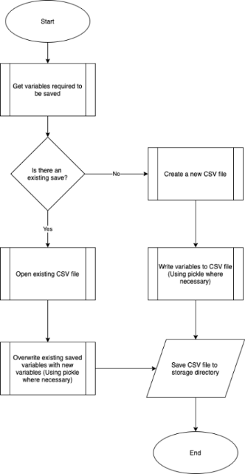

### ▮ Pausing

When pausing my solution, I will use the *threading* module. This will allow me to continue executing certain portions of code while not executing other portions. If I were to use the *time* module to pause code execution, the window would freeze, meaning the user could not click buttons on the pause screen such as settings or save game. The use of the *threading* module means I can pause code execution such as enemy and player movement, status bar drain, certain time-keeping clocks, while keeping the window of the game active.

Below is an overview for the pausing algorithm:

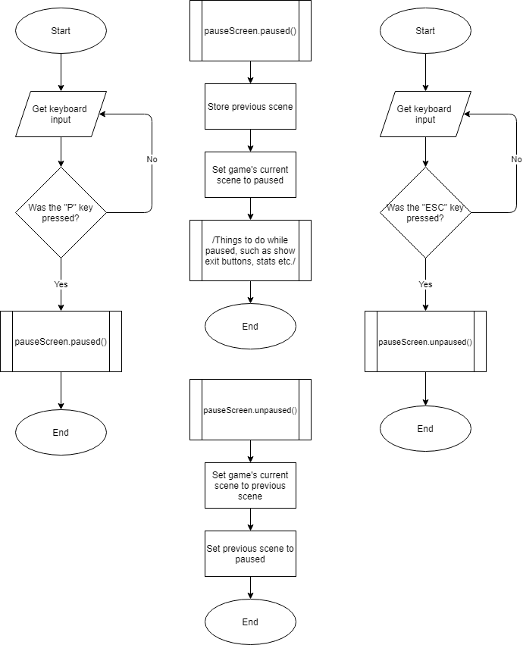

### ▮ Map Generation

To generate the dungeon map. I will use the *random* module. When deciding what kind of room can fit in the current layout, there will be several options. If a room has an exit to the south, there will be 7 rooms that could fit as the next room. I will use the random module to randomly select a room to be used. This will make the rooms feel more confusing and maze-like and will prevent the dungeon floor looking and feeling similar.

Below is an overview for the map generation algorithm:

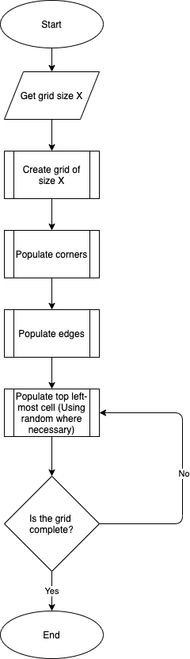

### ▮ Player handling

I will inherit the player class from the Pygame Sprite class. This way I can easily implement all the collision detection and movement logic. Having my player class inherit from the Sprite class allows me to add the player to a group of Sprites, allowing to easily draw all sprites on to my window at once.

## ▮ Key classes

### ▮ Data Handling

TO BE ADDED

### ▮ Pausing

No classes are involved in pausing my game. When the game must be paused, the “scene” of the game will be changed to the pause scene, and all execution of code in other scenes (like the planet scene, dungeon scene, inventory scene etc.) will stop. This accomplishes the criteria for a pause function in a clean simple manner.

### ▮ Map Generation

The map generation will be composed of 3 classes:

#### ▮ Dungeon class

|  |  |  |
| --- | --- | --- |
| Name | Type | Description |
| numberOfFloors (parameter) | Integer | Contains how many floors the dungeon has |
| floorRadius (parameter) | Integer | Contains how wide each floor is. A floor radius of 7 would yield a 7 by 7 floor. |
| map | List | Contains all the “floor” objects |

#### 

When taking these parameters, I will have to do some input validation. Obviously, you cannot have a floor that is negative in radius or have a dungeon that has a negative number of floors. To keep my program from having to calculate too much, I will also cap the radius of each floor to 21 (I may add a slider for the user to change how big they would like the dungeon), and I will cap the number of floors to 7 (again, I may add a slider, however this is non-essential and so is not a top priority). To keep the game interesting and challenging, I will implement a minimum of 2 floors and a 7 radius.

IF numberOfFloors < 2 THEN

numberOfFloors = 2

ELSEIF numberOfFloors > 7 THEN

numberOfFloors = 7

ENDIF

IF floorRadius < 7 THEN

floorRadius = 7

ELSEIF floorRadius > 21 THEN

floorRadius = 21

ENDIF

#### ▮ Floor class

|  |  |  |
| --- | --- | --- |
| Name | Type | Description |
| min | Integer | Contains the smallest index for the mapGrid |
| max | Integer | Contains the largest index for the mapGrid |
| mapGrid (parameter) | List | Contains an array with lists of “room objects |

#### ▮ Room class

|  |  |  |
| --- | --- | --- |
| Name | Type | Description |
| exit | Dictionary | Contains cardinal directions and whether or not the room has exits in those directions |
| image | String | Contains the file path to the room’s image to be displayed in the window |
| gridIndex | Tuple | Contains the room’s Y and X position within the floor |

### ▮ Player Handling

When handling the player, I will use a few classes;

#### ▮ Player class

|  |  |  |
| --- | --- | --- |
| Name | Type | Description |
| health | Integer | Contains how much health points the player has (variable, so I can change it if necessary e.g. a potion to add extra hearts) |
| speed | Integer | Acts a scale-factor for how fast/slow the player moves on the screen |
| movement | String | Contains the direction the player is moving, useful for doorways etc. |

#### ▮ Inventory class

This will be an attribute of the player class

|  |  |  |
| --- | --- | --- |
| Name | Type | Description |
| inventoryList | List | Will act as the actual inventory, holding all the Item objects that the player has |
| max | Integer | Contains the maximum number of items the inventory can hold |

## ▮ Post-development Data

Once the game is completed, no post-development data needs to be imported.

# Implementation

## ▮ Window Setup

All good games need a GUI, and that’s exactly where I’ll start! I use a GUI module called Pygame. This module allows me to easily make a window, blit sprites to that screen and most importantly it handles collisions and keyboard detections for me.

I’ll make a Game class to be able to create the window;

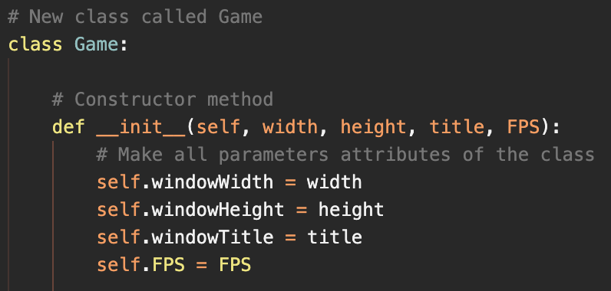

Passing these parameters allow me to easily change the size of the window, and title of the window and the refresh rate and which Pygame updates the window with the FPS value. Creating and setting up the window will take a fair bit of code so I’ll pop it into a separate method called createGame;

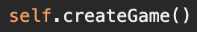

And here is the method;

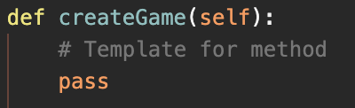

In order to properly set up a Pygame window (and to make it easier to add sounds in the future), I need to initialise Pygame, and Pygame’s built-in mixer;

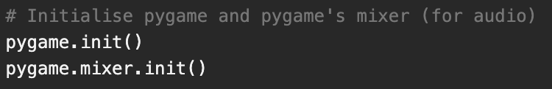

Now that everything is initialised, I can create the window. First I need to make a window with the attributes that I set up earlier, then set the title of the window, and finally create a Pygame clock to make sure the game runs at the specified FPS;

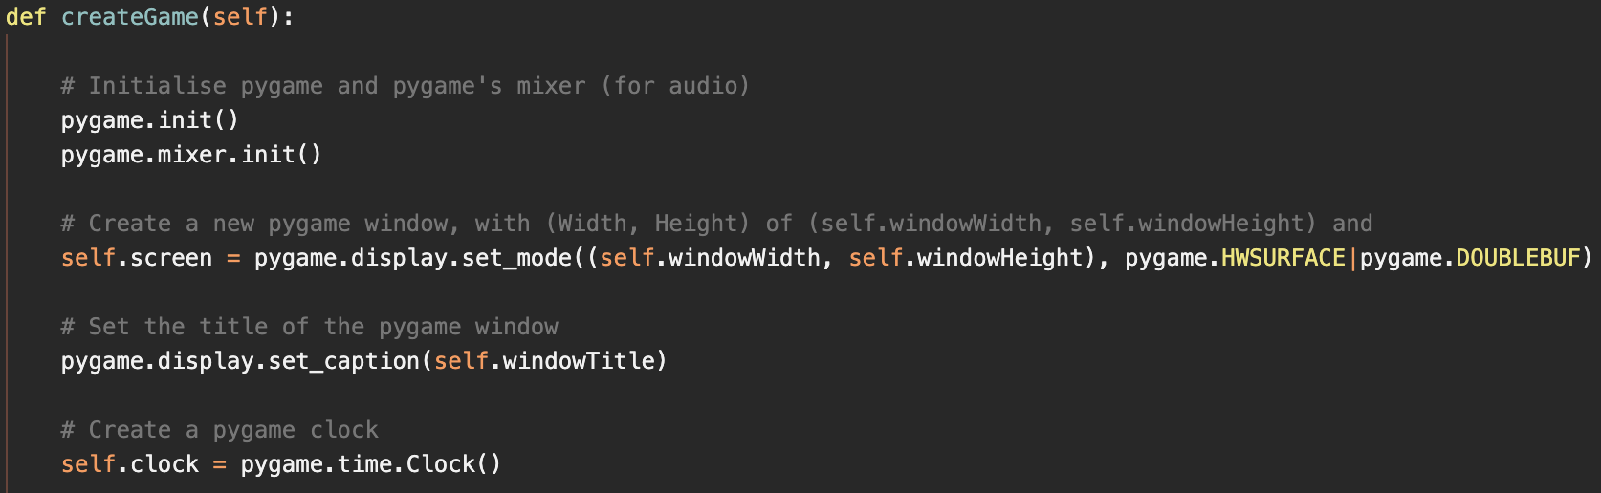

When creating my window, I used pygame.HWSURFACE and pygame.DOUBLEBUF. These tell the window to run in a specific way:

* pygame.HWSURFACE stands for “Hardware Surface”. This tells the window to store sprites and surfaces etc. on video card memory as opposed to RAM. This is done as it is quick for the GPU to process the graphics straight from it’s onboard memory rather than getting the data from RAM, as the bandwidth between the GPU and RAM can sometimes be slow. This speeds up responsiveness.
* pygame.DOUBLEBUF stands for “Double Buffer”. This tells the window to use a separate “block” of memory to apply all drawing methods, then copying that block to video memory as a single operation. This prevents artifacts such as ghosting, or weird flashing of images on the screen.

Currently though, nothing happens. This is because a loop is needed to handle all events, and update the window, and it must run at the FPS I specified. I’ll make a loop inside the constructor method (__init__) of the class;

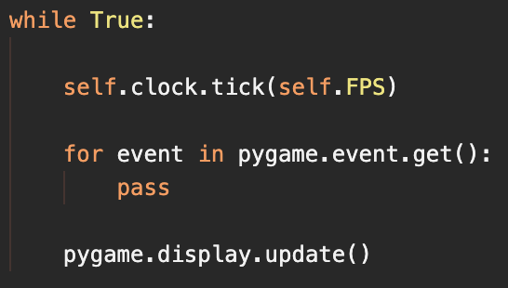

Now I can instantiate the class;

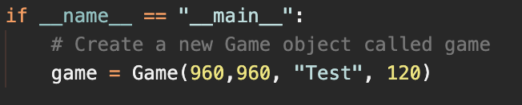

The __name__ line ensures that this current file (main.py) is run directly, and not called from another file. This prevents me accidentally recursively creating loads of windows.

|  |  |  |  |
| --- | --- | --- | --- |
| Test | Expected Result | Actual Result | Pass or Fail |
| Run main.py | A blank window should appear, that is 960x960, title of “Test”. | A blank window appears, that is 960x960, title of “Test”, but cannot be closed | Fail |

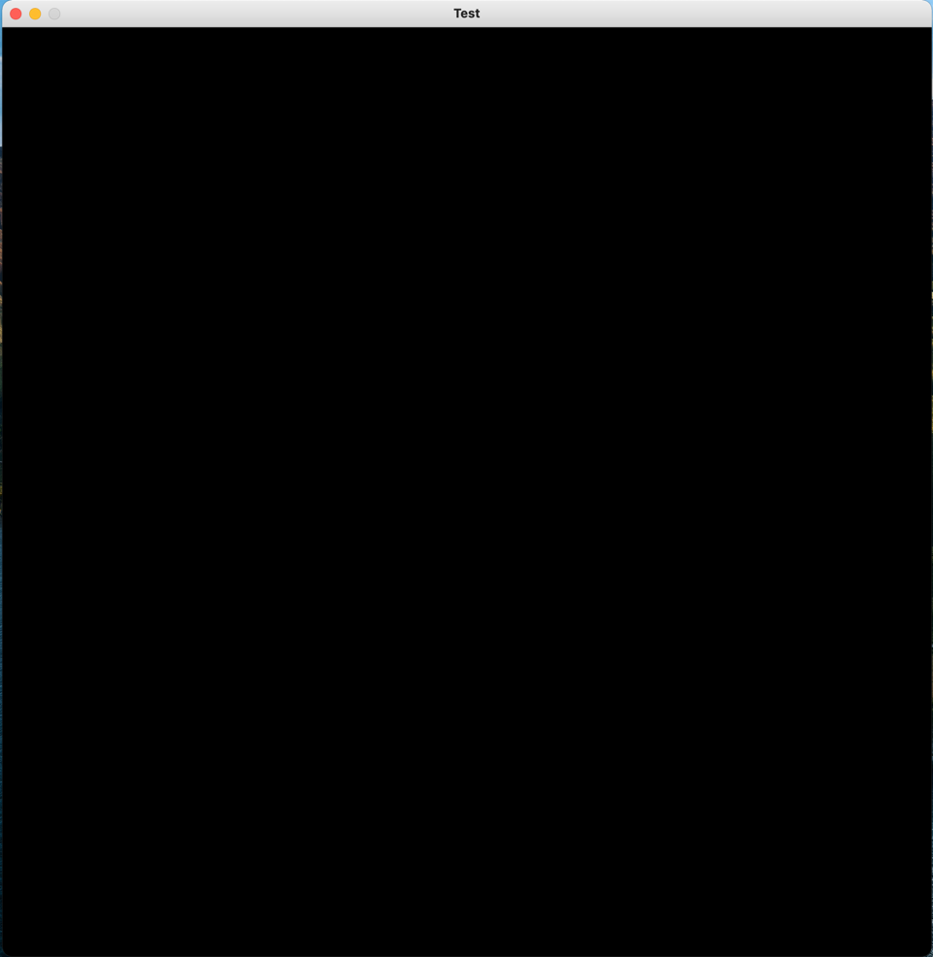

But I soon realised that you can’t actually close the window using the close button, and you have to end the task in Activity Monitor / Task Manager. I quickly had a look at the Pygame documentation and realised I needed to have a quit event detection in my loop, and that I need a “running” variable to manage the while loop. To cleanly and efficiently close the window, I need to use the “sys” module, so I imported that along with Pygame at the top of my program.

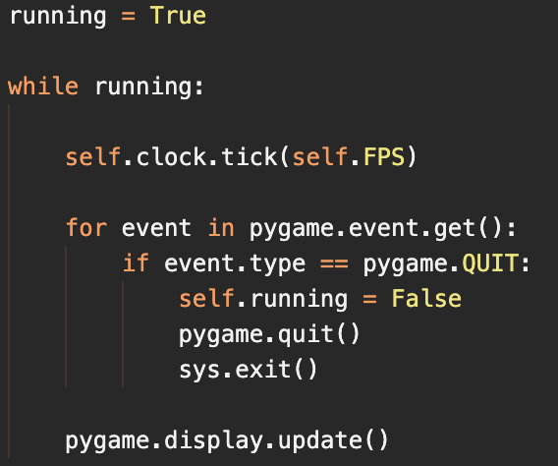

Now the window can be closed without having to end the Python process. Next is time to implement the pause function.

## ▮ Pause Function

To manage different aspects of my game, I will incorporate a “scene” method. I will have an attribute that holds the current scene of the game, and then I can do different things to the window depending on the scene. Inside createGame(), I’ll define the scene attribute to be “dungeon” by default;

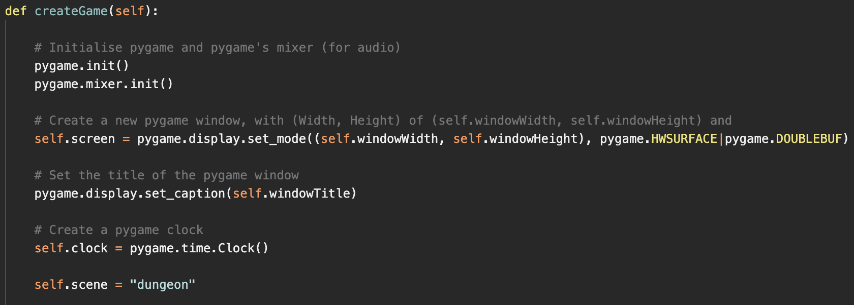

Now in my loop in the constructor class, I can detect the scene and do certain things;

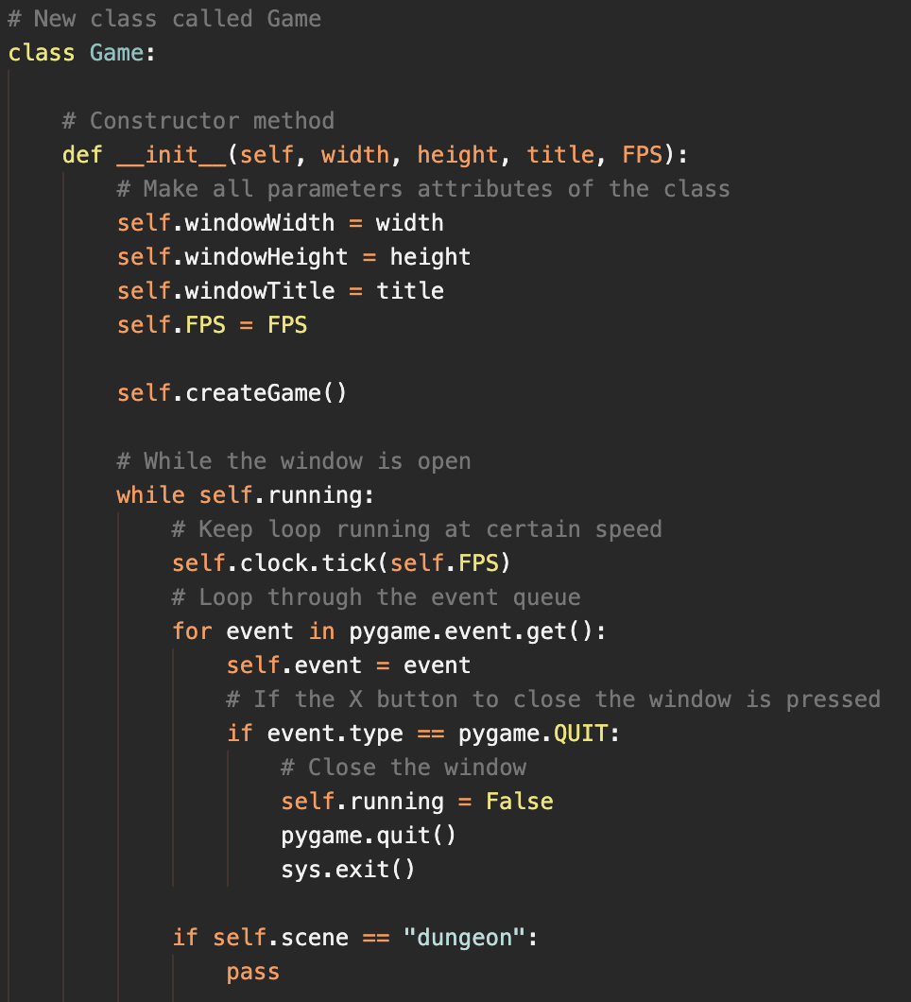

To keep everything clean, I’ll put all the code for each scene in a separate method, called update[Scene Name](), so I need 2 methods as of now, updateDungeon() and updatePause(). Since dungeon is the default scene, I need to put the key press detection in the updateDungeon method. This means the method needs to know the current event;

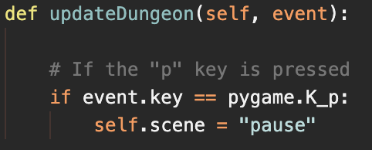

Now if I add another scene detection in the loop, it should pause all other portions of code, and only execute what is in the updatePause method. This means that I won’t have to use the *threading* module like I was planning to and that means my code will run smooth and be less complex. By creating the updatePause method, adding a pause scene detection to the loop, and by filling the screen red if it’s paused;

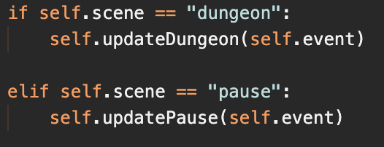

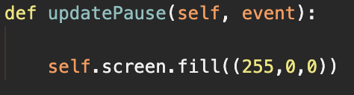

When pressing p on the window, it brings up;



But there is no way to get back to the dungeon scene; there is no point pausing if you can never un-pause! I’ll use the escape key to get out of the pause scene;

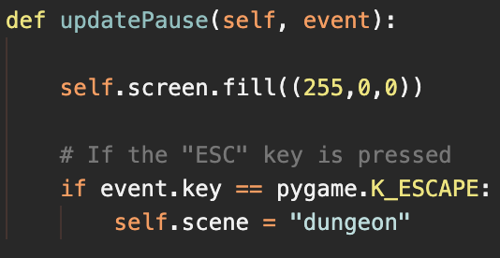

Now I can enter and exit the pause menu, and while paused everything else won’t be executed. The next key-aspect is the player.

## ▮ Player Movement and Handling

As I said in my design, my player class will inherit from Pygame’s Sprite class. To keep everything clean and to keep file size short, I’ll put the player class in a separate file, then import that file in my main.py file. To begin with, the player will just be a coloured shape as graphics aren’t too important at this current time;

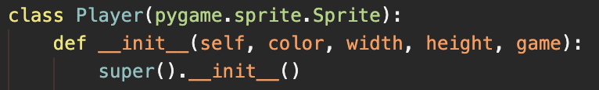

The parameters are as follows:

* color is a tuple with the RGB values of the shape e.g. (255, 0, 255)
* width and height are the dimensions of the shape of the player
* game is the Game class so I can access it’s variables within the Player class.

First I need to make the pygame Rect object, this will enable me to have the player collide with other Rect objects;



The 2 zeros are the Rect’s x and y position, so (0, 0) is the top-left corner of the screen. Now I can draw the shape;



Now going back to the Game class in the main.py file, I can create a new player attribute using this new Player class;



|  |  |  |  |
| --- | --- | --- | --- |
| Test | Expected Result | Actual Result | Pass or Fail |
| Run main.py | There should be a yellow square of 72x72 in the top-left of the window | There is a yellow square of 72x72 in the top-left of the window | Pass |

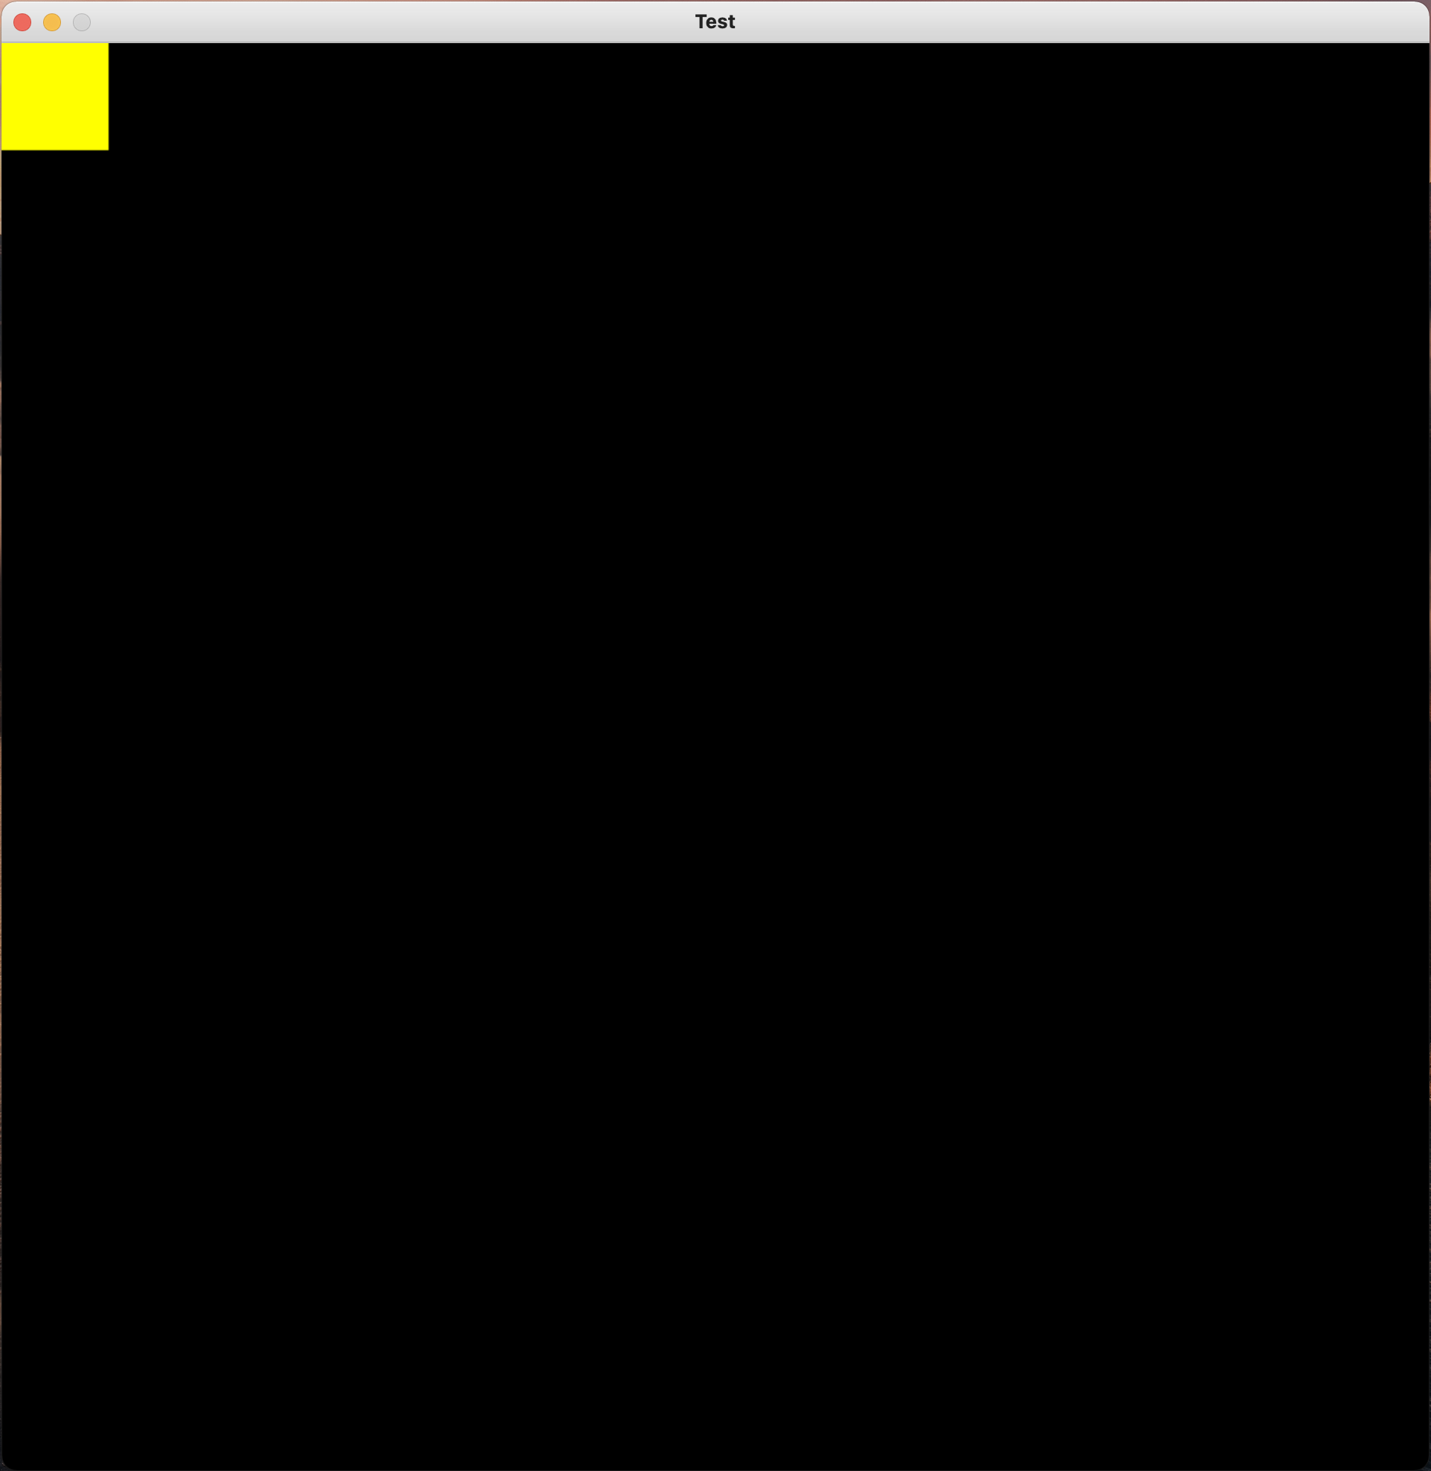

Now to get the player moving. Pygame’s keyboard detection is very simple and makes this easy. I’ll make an update method in the Player class that takes an “event” parameter. This method will be called from the Game class, so by passing it the event from the event loop, I can easily access all the pressed keys.



Now I need to distinguish the events, again Pygame makes this really simple. All I need to do is check if the “event” is a Keydown event (which means a key has been pressed) then see check the event’s key to determine what to do;

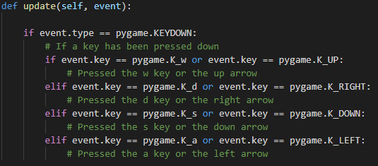

Now I just need to adjust the player’s position depending on what key they press. Since the player is blitted at it’s Rect’s co-ordinates, I can just change the Rect co-ordinates (this will also keep collision detection behaving as it should);

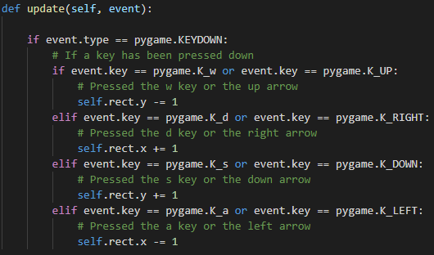

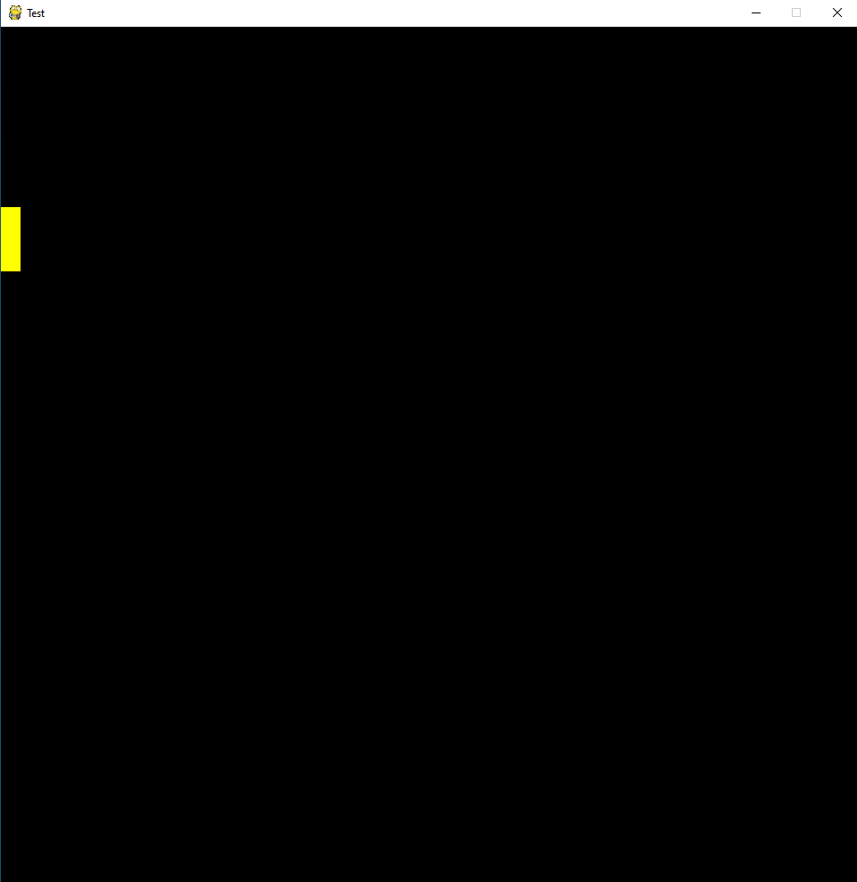

While this solution works, there are quite a few problems that I will attempt to fix:

1. Holding down a key does not continuously move the player.
2. You can’t move in 2 directions at once e.g. you can’t move diagonally upwards.
3. You move very slow
4. As shown, the player can move off the screen.

Firstly, if you were to hold down the W key for example, you would expect the player to constantly move up, but currently the player moves upwards once, then stops. I had to do a bit of searching to find a solution for this. I managed to find a solution on this [Stack Overflow](https://stackoverflow.com/questions/9961563/how-can-i-make-a-sprite-move-when-key-is-held-down) page (<https://stackoverflow.com/questions/9961563/how-can-i-make-a-sprite-move-when-key-is-held-down>) where the original poster accepted [this](https://stackoverflow.com/a/9961598) answer (<https://stackoverflow.com/a/9961598>). I implemented this into my game, making the movement logic now look like this;

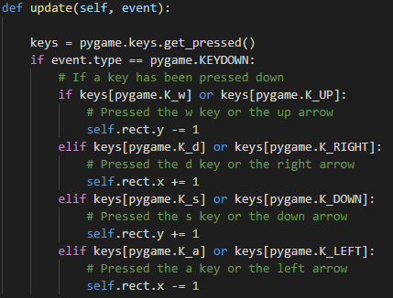

And this fixed the holding key issue nicely.

Moving onto the second issue, bidirectional movement. This took me quite a while to figure out but was quite simple. In my movement logic, I was using elifs instead of ifs. This meant the player could only enter one of the branches at any one time. Changing these elifs to ifs fixed the problem.

Thirdly, movement speed. This was due to the fact I am only changing the player’s Rect’s co-ordinates by 1. I can solve this problem by scaling that up a bit. To do this I will have a “base” value which I will then multiply by a variable called speed (which will be set to 3 by default). This means I can change how fast the player moves which could be useful if I add some mud and want the player to slow down, or some Hermes boots that make you go fast;

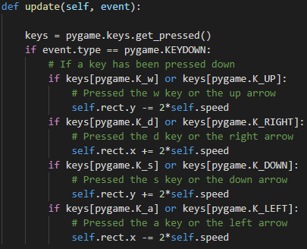

Lastly, being able to leave the screen. All I need to do is keep an eye on the player’s Rect’s co-ordinates, and make sure they don’t go below 0, or beyond the width/height of the window, minus the width/height of the player. I did a little bit of research to find the best way to implement this and found another [Stack Overflow page](https://stackoverflow.com/questions/43142342/how-can-i-stop-a-character-in-pygame-from-leaving-the-edge-of-the-screen) (<https://stackoverflow.com/questions/43142342/how-can-i-stop-a-character-in-pygame-from-leaving-the-edge-of-the-screen>) with [this](https://stackoverflow.com/a/43142600) answer (<https://stackoverflow.com/a/43142600>). I worked this into my code, giving;

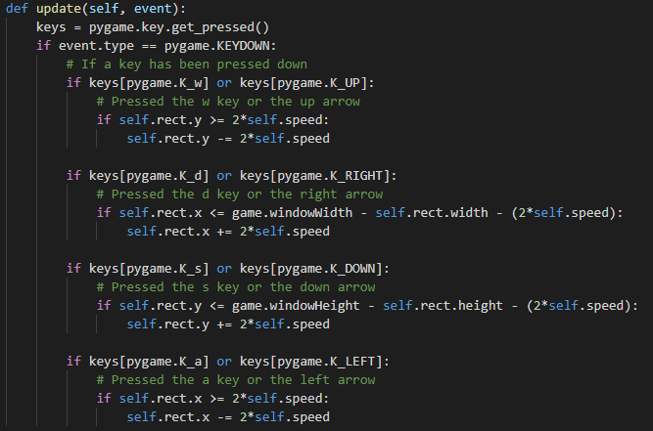

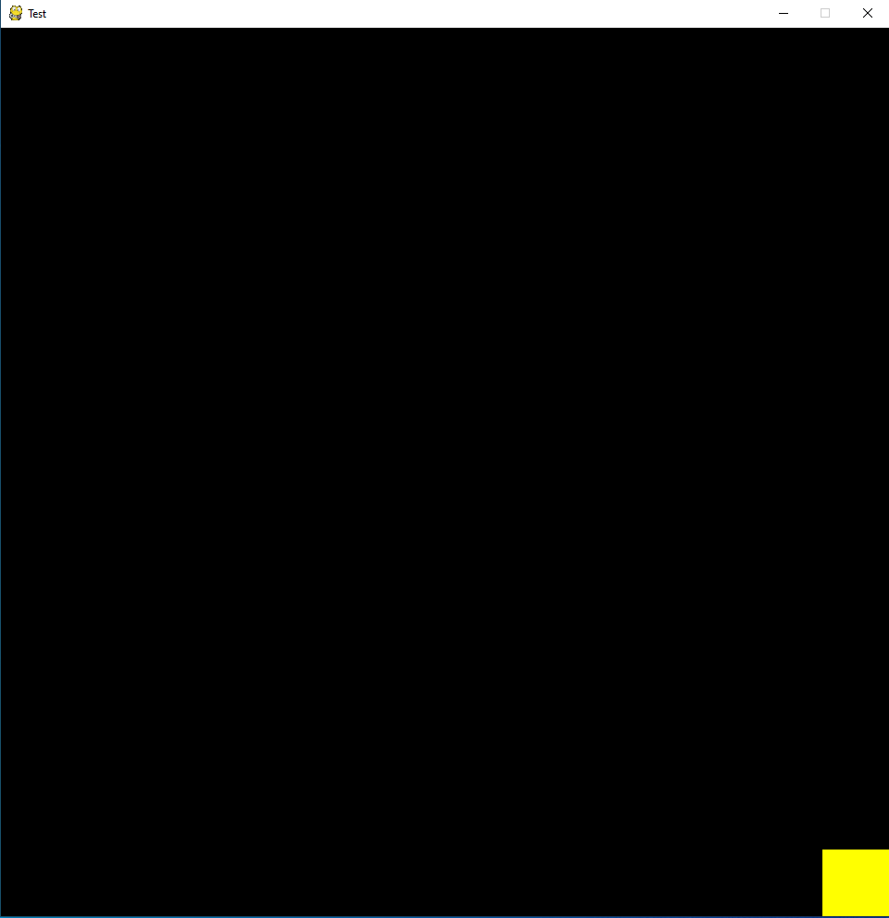

Meaning player movement is done!

## ▮ Map Generation

For the random generation of the dungeon, I will decompose the entire dungeon into several parts:

Decomposing in this way allows me to have full control over each individual room in each individual floor of the entire dungeon.

I started by making a Room class:

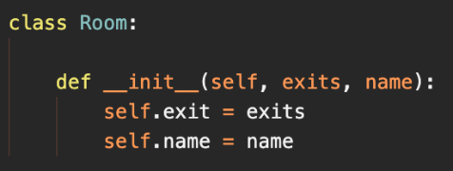

There are 11 possible room layouts:

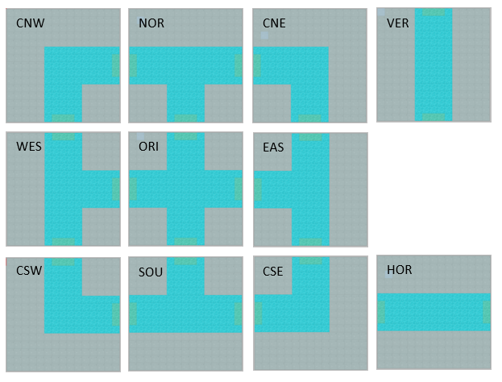

I made a room object for each possible layout. Below is the **CNW** as an example:

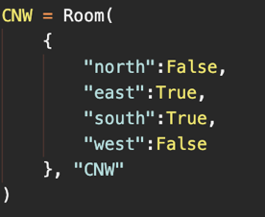

This room class is passed 2 parameters, a dictionary, and a string. The dictionary contains the cardinal directions that you can leave the room from. In this case, you can leave the **CNW** room via the East and South. The string is simply a name for the room.

Each floor of the dungeon will be stored as an array of size X. It is important to make the size of the array changeable in case I need to adjust it in future. I created this floor class:

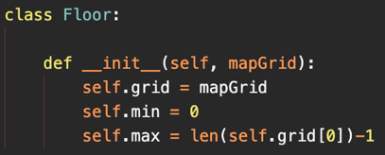

This floor class is passed 1 parameter; an array with placeholder values. I started with a 7 by 7 array:

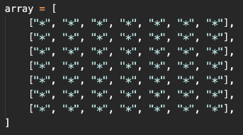

To populate the array with rooms that fit together, I will insert a room into the array line by line, from left to right. Like solving a puzzle, I will generate the corners and sides first. The corners of the array can only be 1 room, and the sides of the array can only be 1 of 2 rooms. I created a procedure to populate the array:

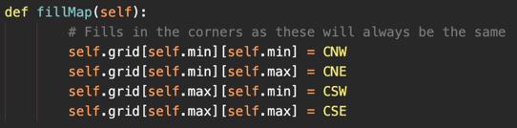

Then I can populate the sides of the array:

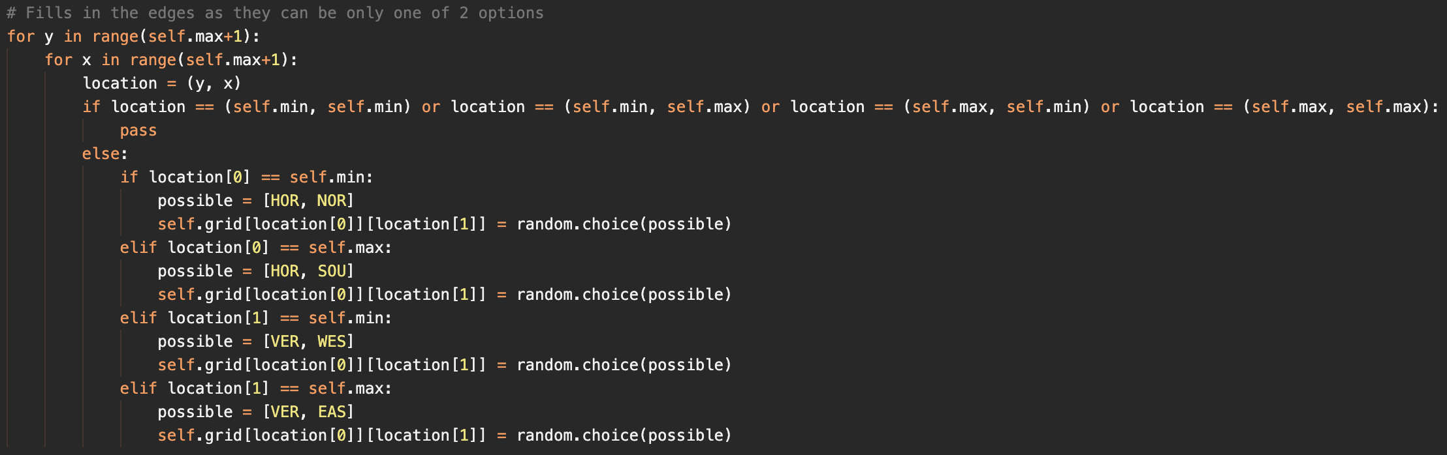

|  |  |  |  |
| --- | --- | --- | --- |
| Test | Expected Result | Actual Result | Pass or Fail |
| Run fillMap() and print the new array | The new array has its corners and sides populated | The new array has its corners and sides populated | Pass |



This is difficult to read however, and it does not tell you what kind of room is in each cell. I wrote a bit of code to translate this mess into something a bit more readable:

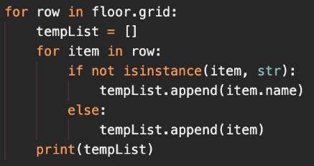

Which outputs this:

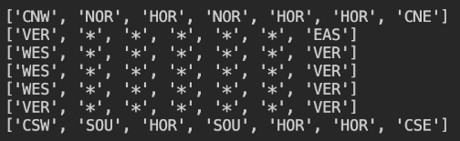

Now that the outer edges of the array are populated, I need to populate the centre of the array. For the rooms to connect properly, the algorithm must know what room is above, below and to the sides of the current room. I will create a function to find the room next room in each direction:

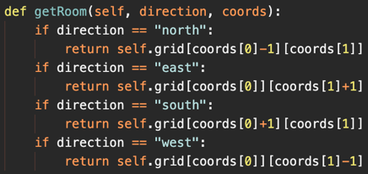

|  |  |  |  |
| --- | --- | --- | --- |
| Test | Expected Result | Actual Result | Pass or Fail |
| Run getRoom(“south”, (1,1)) | The procedure returns “*” | The procedure returns “*” | Pass |

When populating a given cell of the array, the room above and to the West need to be checked for openings. I can use the procedure above to get the given room, then access that room’s exit dictionary to see if it has an opening. There are several possibilities I need to account for when deciding what room to use. The amount of possibilities is given by:

$$Possibilities=Options^{Number Of Times}$$

There are 2 options, the room above and to the west can either have an opening, or not. The number of times is the number of rooms that must be checked, in this case it is 2. We can see that the number of possibilities is 22. 2n can be modelled using binary; 00, 01, 10 and 11. The first digit will represent the North room and the second digit will represent the West room.

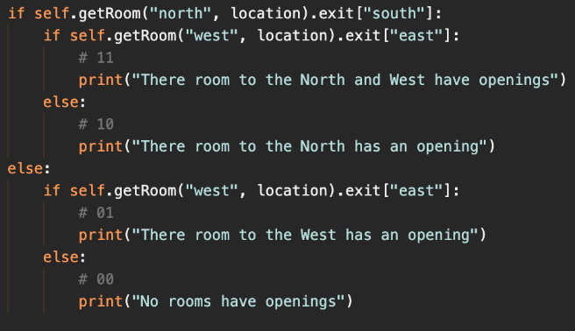

|  |  |  |  |
| --- | --- | --- | --- |
| Test | Expected Result | Actual Result | Pass or Fail |
| Detect adjacent rooms for cells (1,1) to (1,6) | The console outputs one of the 4 print statements | AttributeError: 'str' object has no attribute 'exit' | Fail |

This error was caused by the room to the West being “*” and not a room object. To validate the input for the check, I need to make sure that the room to the West and the North are not strings:



|  |  |  |  |
| --- | --- | --- | --- |
| Test | Expected Result | Actual Result | Pass or Fail |
| Detect adjacent rooms for cells (1,1) to (1,6) | The console outputs nothing when the room to the North and West are not strings | The console outputs nothing when the room to the North and West are not strings | Pass |

Now that the algorithm knows what the rooms around the current room look like, I can decide what rooms would fit best. I need to know what rooms have exits for a specific direction. I edited my Room class to include some class variables to hold what rooms have exits to the North, South, East and West:

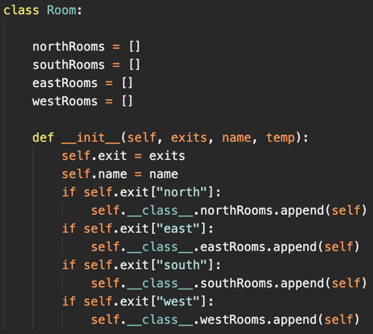

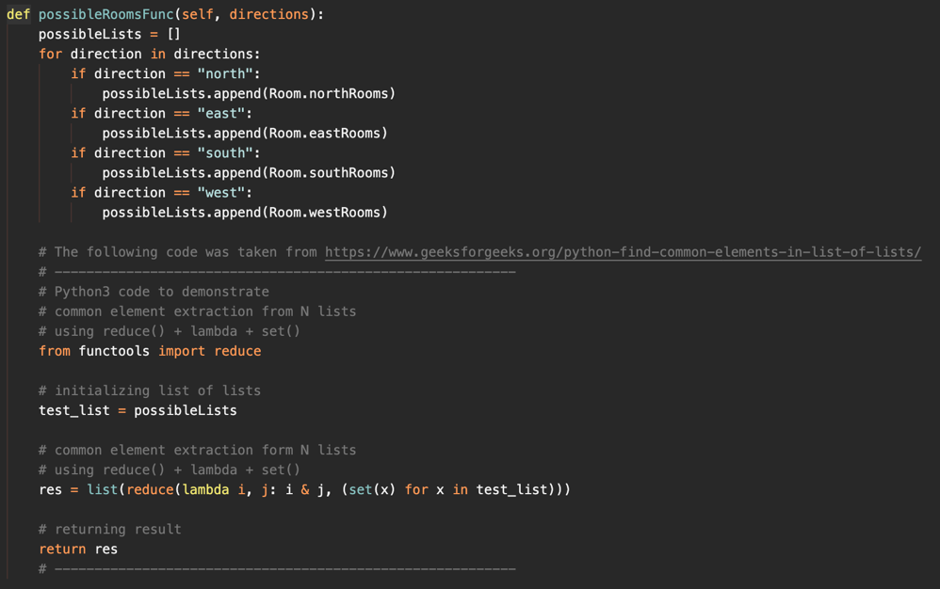Depending on what rooms are adjacent to the current room, the rooms that would fit will change. Using the 11 (North and West rooms have an opening) as an example, we need a room that has an exit to the North **and** to the West. This means I need to find an element that is in both the northRooms list **and** the westRooms list. I used a procedure from GeeksForGeeks to do this, as well as a bit of my own code to determine what lists must be checked. (See here <https://www.geeksforgeeks.org/python-find-common-elements-in-list-of-lists/>)

|  |  |  |  |
| --- | --- | --- | --- |
| Test | Expected Result | Actual Result | Pass or Fail |
| Create a floor and populate cell (1, 1) with an accessible room | The cell (1, 1) is populated with an accessible room | The cell (1, 1) is populated with a room creating dead ends | Fail |

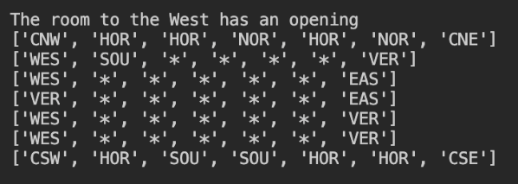

Using the top-leftmost 4 cells, we can see that the algorithm has generated:

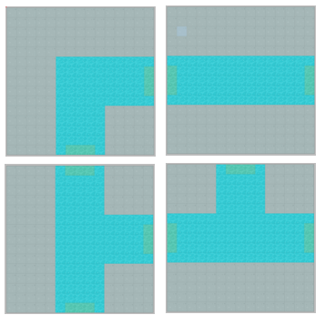

The bottom-right room has a North exit that leads to nowhere. This occurred when the room to the West had an opening, but the room to the North did not (01). This means that in situations like this, not only do I have to find the common elements in N lists, but also remove common elements from another list. I did this by passing a function 2 lists; 1 list with the directions that must be included and another list with directions that must **not** be included. The example above would be:



I need to run the first parameter through the function that returns the common elements of N lists, then compare the returned list against the second parameter to remove common elements. I used a portion of code from StackOverflow to do this, along with my own code. (See here <https://stackoverflow.com/questions/13672543/removing-the-common-elements-between-two-lists>)

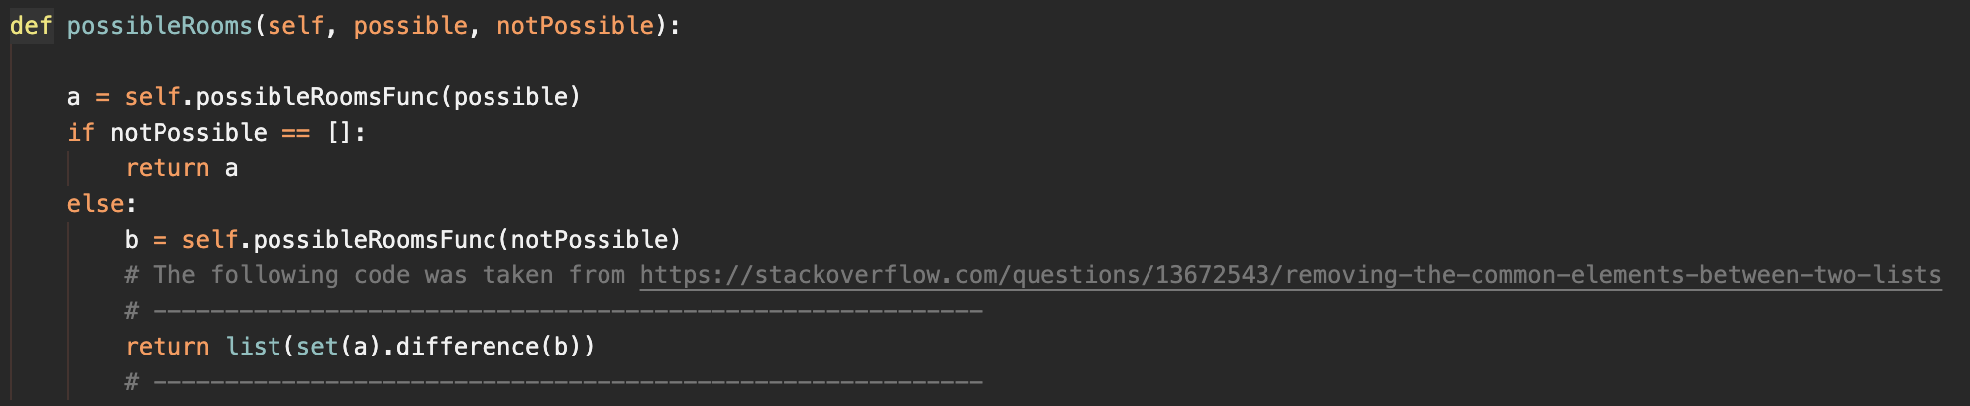

|  |  |  |  |
| --- | --- | --- | --- |
| Test | Expected Result | Actual Result | Pass or Fail |
| Create a floor and populate cell (1, 1) with an accessible room | The cell (1, 1) is populated with an accessible room | The cell (1, 1) is populated with an accessible room | Pass |

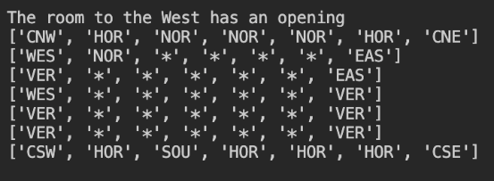

Using the top-leftmost 4 cells, we can see that the algorithm has generated:

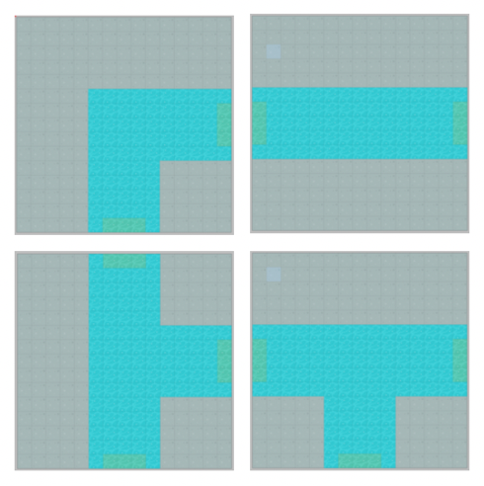

Which is valid and accessible. The algorithm works well for most of the cells, but when the algorithm gets to the penultimate column in the array, it will have to check both the room to the North and West, but also the room to the East. Using the possibility equation before, we can see there are 23 possibilities, which can be modelled as 000, 001, 010, 011, 100, 101, 110 and 111; where the first digit represents the West room, the second digit represents the North room, and the third digit will represent the East room:

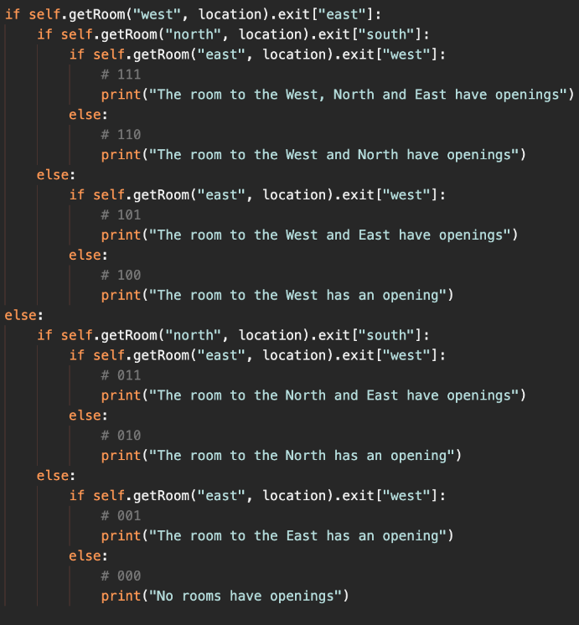

|  |  |  |  |
| --- | --- | --- | --- |
| Test | Expected Result | Actual Result | Pass or Fail |
| Detect adjacent rooms for cells (1,5) | The console outputs one of the 8 print statements | The console outputs one of the 8 print statements | Pass |

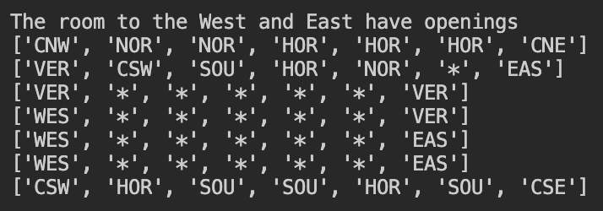

I can adapt the logic I used for many of the cells to be used for the penultimate column. Using the 101 possibility as an example, we need a room that has exits to the West and the East, but **not** the North.



|  |  |  |  |
| --- | --- | --- | --- |
| Test | Expected Result | Actual Result | Pass or Fail |
| Create a floor and populate cell (1, 5) with an accessible room | The cell (1, 5) is populated with an accessible room | The cell (1, 5) is populated with an accessible room | Pass |

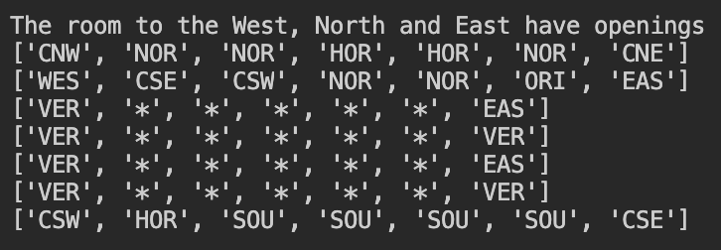

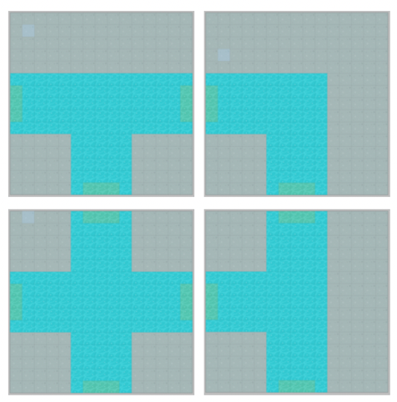

Using the top-rightmost 4 cells, we can see that the algorithm has generated:

Which is valid and accessible.

This version of the algorithm will work for much of the array, but there are 2 more scenarios that trips it up. When the algorithm reaches the penultimate row of the array, it must check different directions than the penultimate column. Rooms to the North, West and South must be checked. This is extremely like the code above and was very easy to program. The final hurdle is the last unpopulated cell. All 4 cardinal directions must be checked, meaning 24 possibilities must be accounted for:

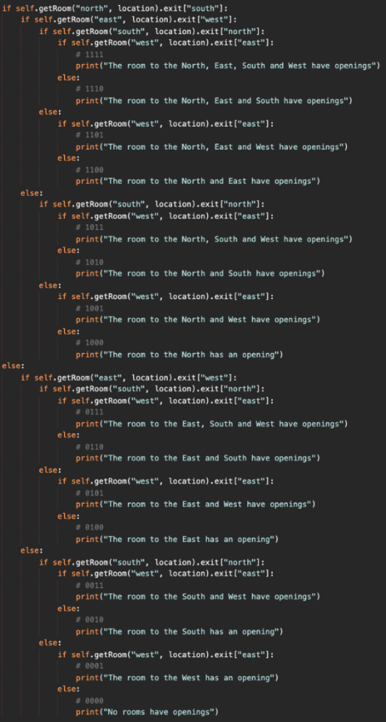

I can further adapt the logic I used for many of the cells to be used for the final unpopulated cell. Using the 1110 possibility as an example, we need a room that has exits to the North, East and the South, but **not** the West.



|  |  |  |  |
| --- | --- | --- | --- |
| Test | Expected Result | Actual Result | Pass or Fail |
| Create a floor and populate all cells | The array is fully populated with accessible rooms | The array is fully populated with accessible rooms | Pass |

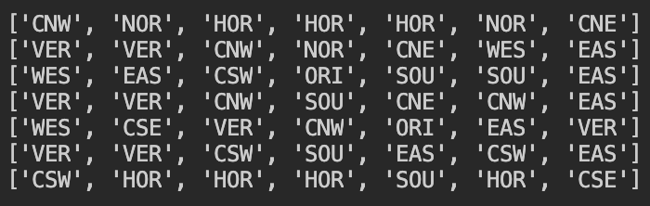

Which looks like:

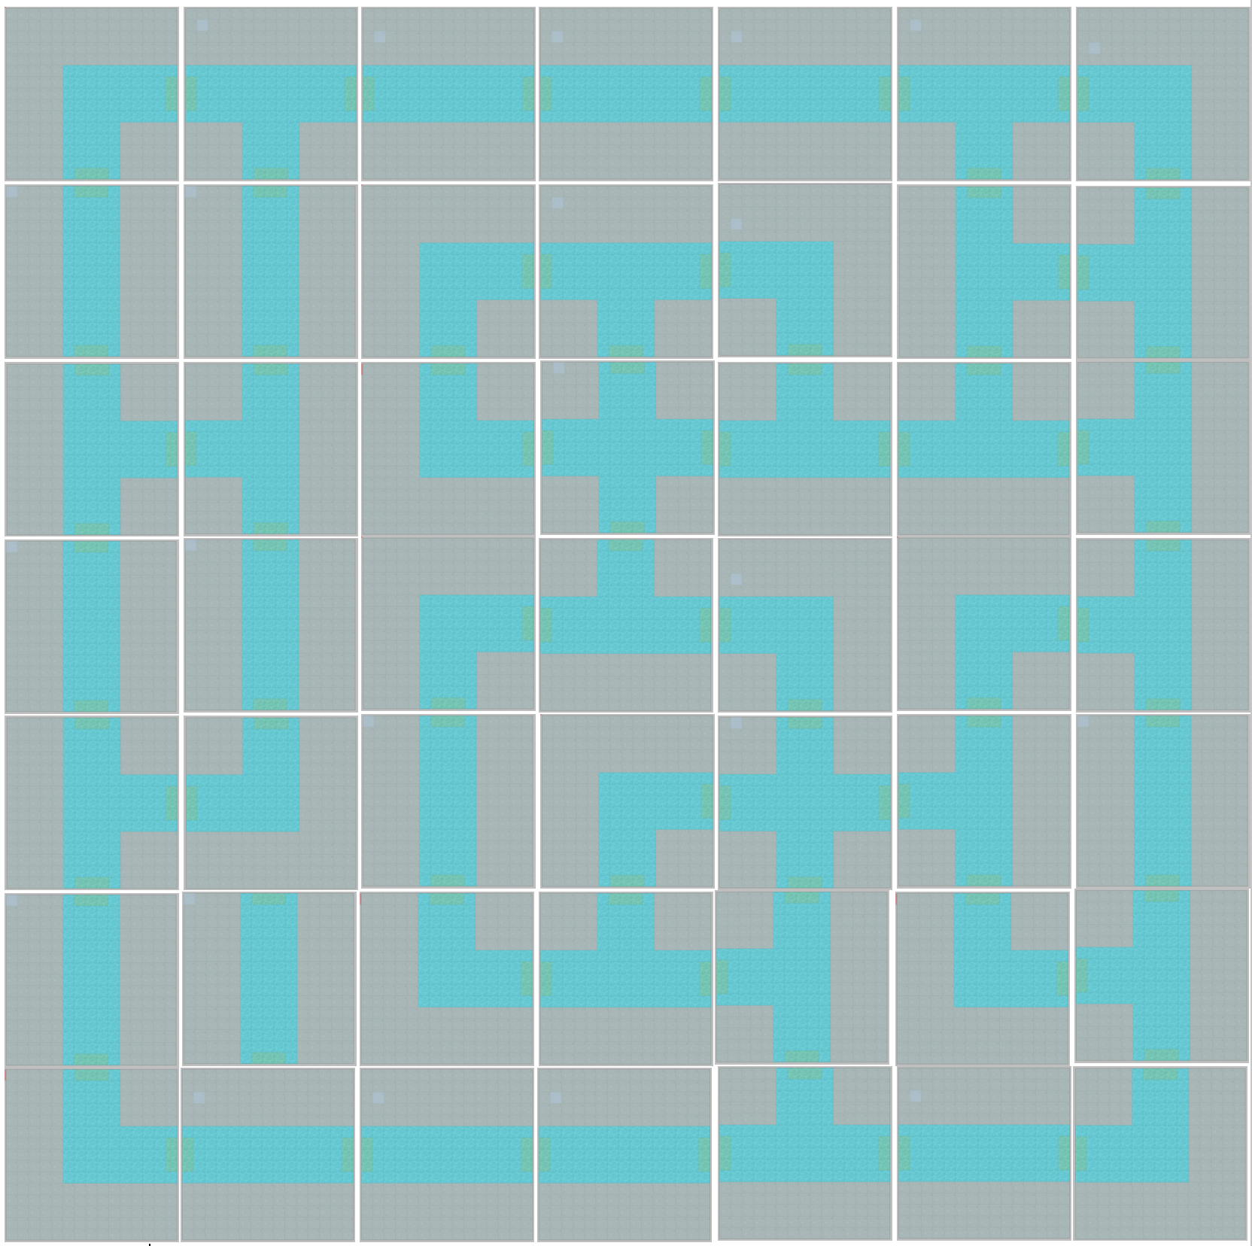

This is a fully functional floor, there are no dead ends and no way to get stuck. This can be added to a dungeon.

I created a dungeon class, as I specified in my design section:

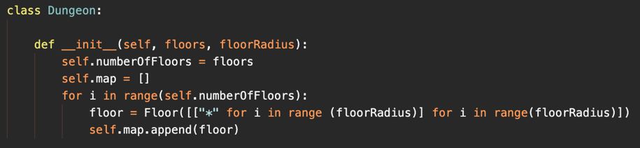

The class uses list comprehension to create a list. It adds numberOfFloor amount of Floor objects to a list, each populated with floorRadius squared number of rooms. The next challenge is getting the map to display on the screen.

## ▮ Tiled Map Creation

To do this I will need to add an image that can be blit on the window. I use a program called Tiled to create my rooms. Tiled allows me to easily import tile sets and add collision boxes (which will be very useful later). I will create a Tiled map for each room, then add the file path to that Tiled file inside of each Room’s blueprint.

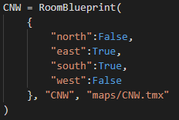

Now that each room has a specified map attached to it, all I need to do is get the current room that the player is in, access its attributes, then blit its image to the screen. The trouble is, Tiled saves it’s files as. tmx extensions and getting .tmx files to blit to a Pygame screen is difficult. I used some code from the KidsCanCode YouTube channel (specifically [this](https://www.youtube.com/watch?v=Mr5l4U9S4kI) video (<https://www.youtube.com/watch?v=Mr5l4U9S4kI)>) and a bit from the Pygame documentation:

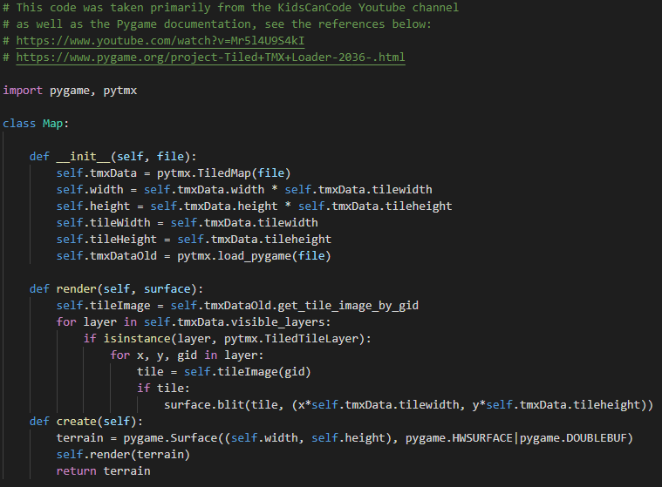

This code can make a new “Map” object everytime the player goes into a new room. To get the current room of the player, I first need to get the current floor of the player, and since you will always start on the top floor, it is quite easy;

self.player.currentFloor = self.dungeon.map[0]

The player’s room cannot change yet since there is no way to exit / enter rooms since I haven’t implemented collision yet, so I will hard-code the players current room just to check if it works

self.player.currentRoom = self.player.currentFloor.grid[0][0]

Now using the Tiled Map code, I can create a new Map object;

self.map = tiledMap.Map(self.player.currentRoom.fileName)

And use that to create a new Pygame surface;

self.mapImage = self.map.create()

Which I can then blit onto the screen;

self.screen.blit(self.mapImage, (0,0))

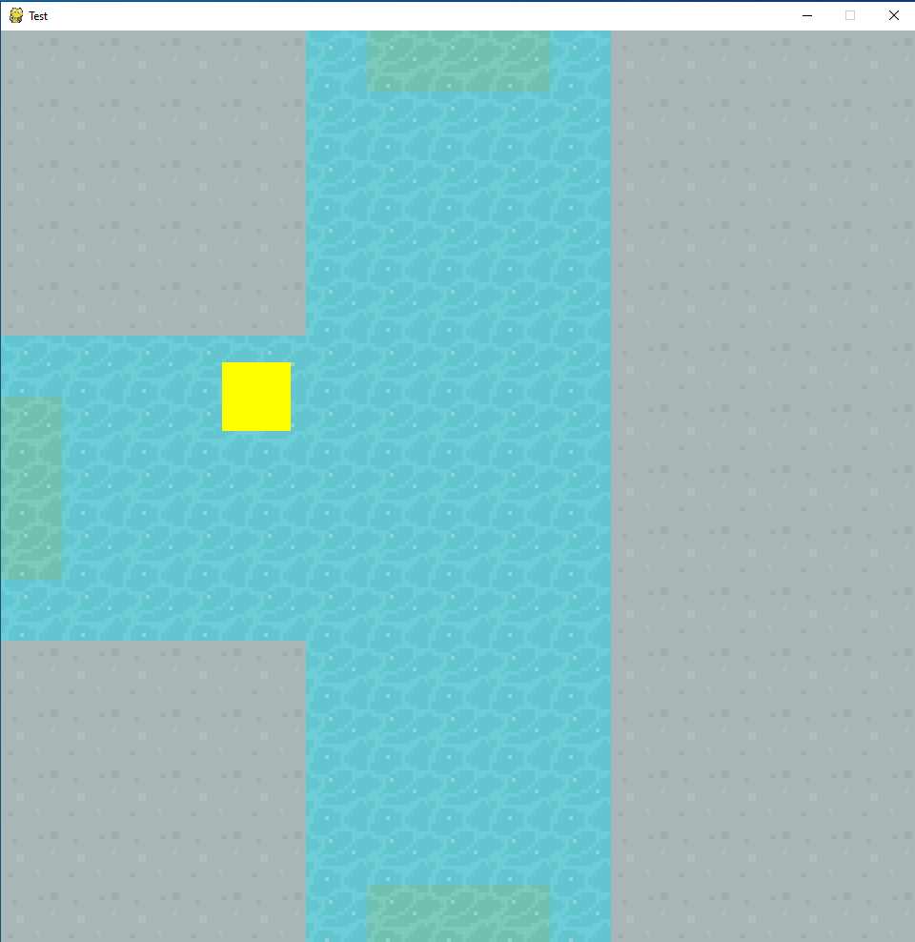

|  |  |  |  |
| --- | --- | --- | --- |
| Test | Expected Result | Actual Result | Pass or Fail |
| Change the .tmx file for a specific room | The change should appear in game | The change does appear in game | Pass |

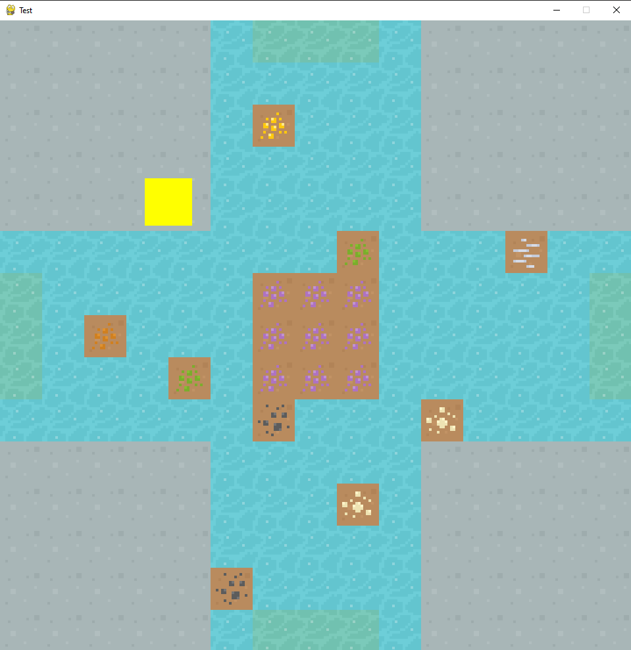

## ▮ Item Generation

I want to easily be able to create items with different attributes such as damage, healing, armour, value etc. I will make an Item class for this, and I’ll make it inherit from the pygame Sprite class. This will make it easy for me to blit it to the window, and for collision detection for when the user clicks on the item;

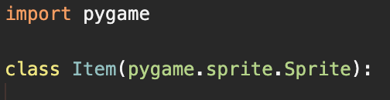

I need to run the constructor method from the parent class;

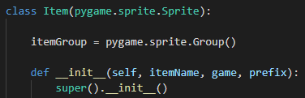

Every item needs a display name (a pretty name that the user can see) and a name that can be referenced inside my code (does not need to be very pretty). I will take the display name of the item (that is a parameter) and create a referable name by turning it all to lower case and separating it with underscores;

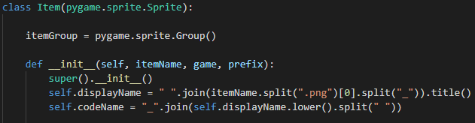

The game parameter is a reference to the Game class that contains the window attribute, and prefix is the folder to find the item’s image in. I will load the image using a combination of the prefix and the itemName, giving me a destination;



Since my image files are only 16x16, I will need to upscale them a bit to make them sizeable enough to fit in with my game;



Next, I need to have items generate in each room. I’ll create a separate file to generate and populate each room with items. I first need to loop through each room in each floor of the dungeon.

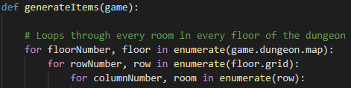

Because each room is going to have a different number of items, I will therefore need to dynamically create variables and the best way to do this in Python is with a dictionary. I will assign a dictionary to each room, then add the Item objects to that dictionary, with dynamically created variables.

For the moment, all the items will be random. I will need to select a random subfolder (this will be the prefix for the item class, such as food, armour, weapons, treasure etc.) and then select a random image from that subfolder (this would be the itemName);



The reason I must check if the first character of the item is not a dot, and that the last characters are .png, is because macOS (my primary development OS, but I do occasionally use Windows) tends to add some sort of “ghost files” that start with a dot and have a different file extension. Checking these allows me to only pick the actual PNG files.

Now I can instantiate a new Item object, and add it to the room dictionary;



Finally, to get the items to show on the screen, I need to loop through the dictionary of the players current room, and draw each item;



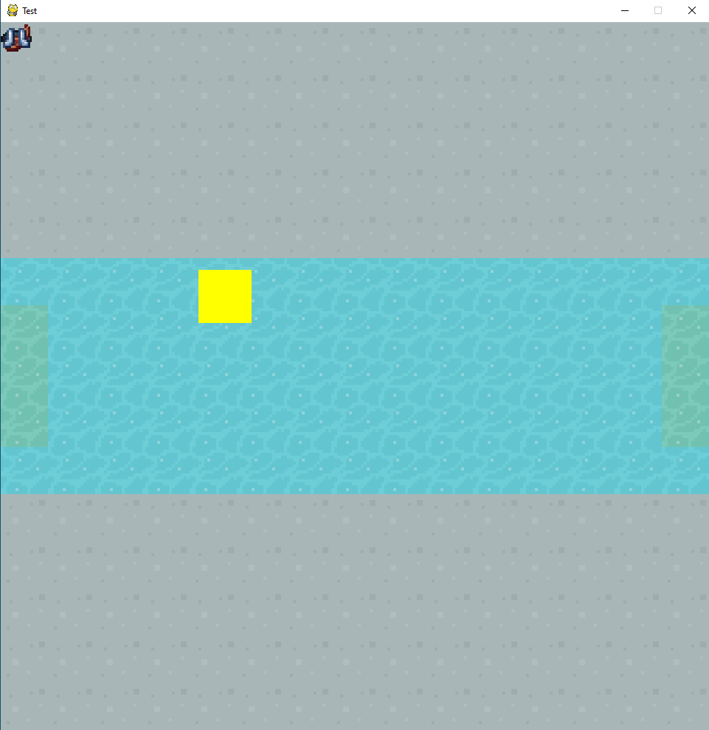

This works, but I did not realise that all the items would generate up in the top-left corner. I need to give each item its own co-ordinates. To make sure the collision detection is maintained, I need to move the item’s “rect”. (A Rect is a Pygame object that you can interact with).

I need to do a bit of calculation to make sure the items cannot generate outside of the screen. The furthest an item can spawn to the left is 0 and the furthest it can spawn to the right is the width or the window minus the width of the item. And similarly, for the Y-axis; the furthest an item can spawn upwards is 0, and the furthest it can spawn downwards is the height of the window minus the height of the item;

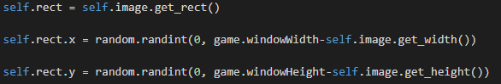

Now if I blit each item at its Rect’s X and Y co-ordinates, they shouldn’t bunch up in the corner;



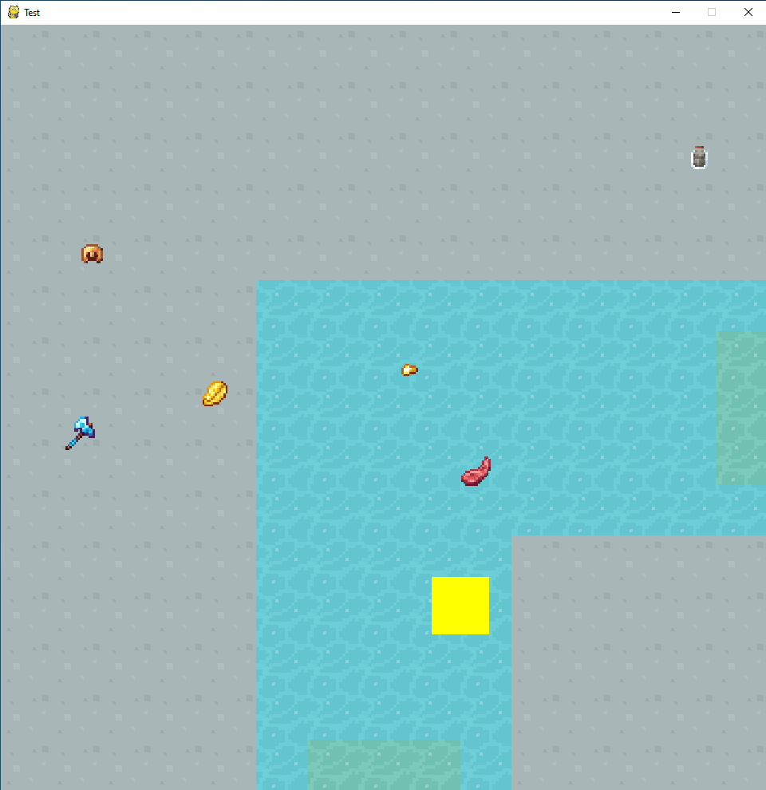

## ▮ Collisions

Now that we have something of a game, I need to implement collision detection. Thankfully, I have made this easy for myself by using Pygame Sprite and Rect objects. Firstly, I will implement the collision for moving rooms.

### ▮ Room Exit Collisions

Going back to the code I used to turn Tiled maps into blit-able maps, there is an extra bit of code to detect when the player collides. In the Tiled editor, you can add collision boxes;

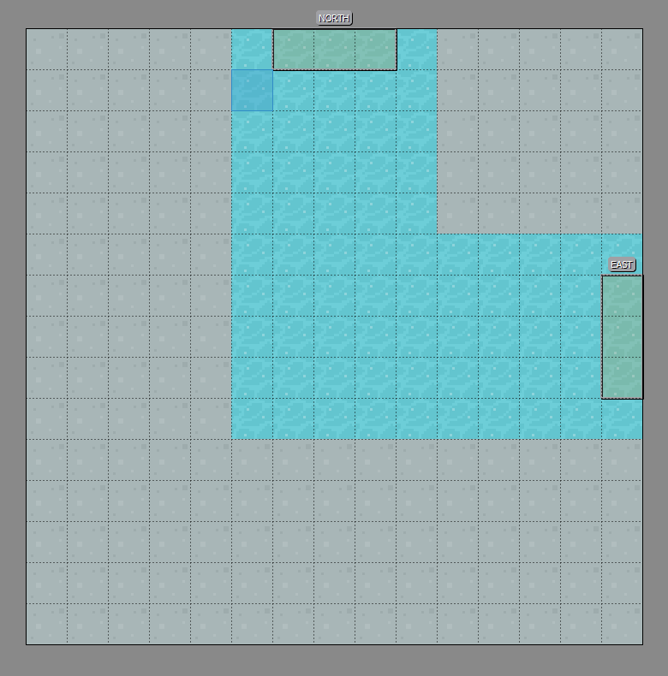

This example from the CSW room has two collision boxes; NORTH and EAST. To detect whether the player collides with these boxes, I need to do a few things;

1. Loop through all collision boxes in the current room
2. Create a Pygame Rect object using the details of the collision box
3. Check if the player’s Rect collides with the new Rect

The following code was taken from the source I referenced in my Tiled Map Generation section.

When creating a map in Tiled, you can create multiple “layers”. These layers can either be Sprite layers (a layer for images) or an Object layer (a layer for collision boxes). I first need to loop through all the layers of the current room’s Tiled file;



Then I need to check whether the current layer is a Sprite layer or an Object layer. The library I’m using (pytmx) has these as 2 different classes, so I just need to check if the layer is an instance of a specific class;

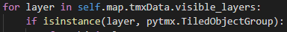

Now that I have identified an Object layer, I need to loop through all the collision boxes on that Object layer;

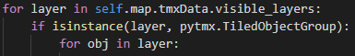

That is the first step done, now I need to create a Pygame Rect using the details of the collision box. When instantiating a Pygame Rect, I need to pass it the Rect’s x, y, width, and height. It’s quite easy to get the x, y, width and height of the current object in the Object layer, and I can then instantiate a pygame Rect;



Finally, I need to see if this Rect collides with the player’s Rect. Thankfully Pygame makes this really easy, and you can now see why I used Rects throughout;



I have detected that the player has collided with an exit. Now I just need to move the player.

Since moving room is something the player does, I will make a new method in the Player class to handle this.



Leaving our final collision detection logic looking like;

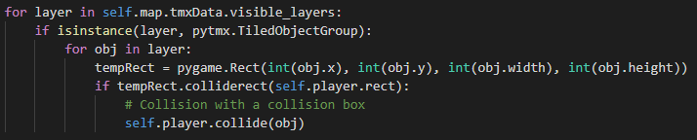

Now the collision box that the player hit will determine what happens next; if they collided with a NORTH box, they need to go to the room above, if they collided with an EAST box, they need to go to the room to the right etc;

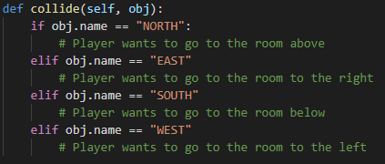

To access the room the player wants to go in to, I need to access the floor the player is on, and then index the floor accordingly. Since indexing arrays work with [Y][X], when moving North, I need to do [Y-1][X], when moving East I need to do[Y][X+1] etc;

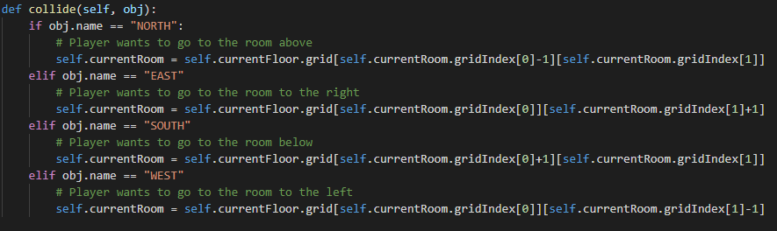

Then I just need to update the game’s mapImage,



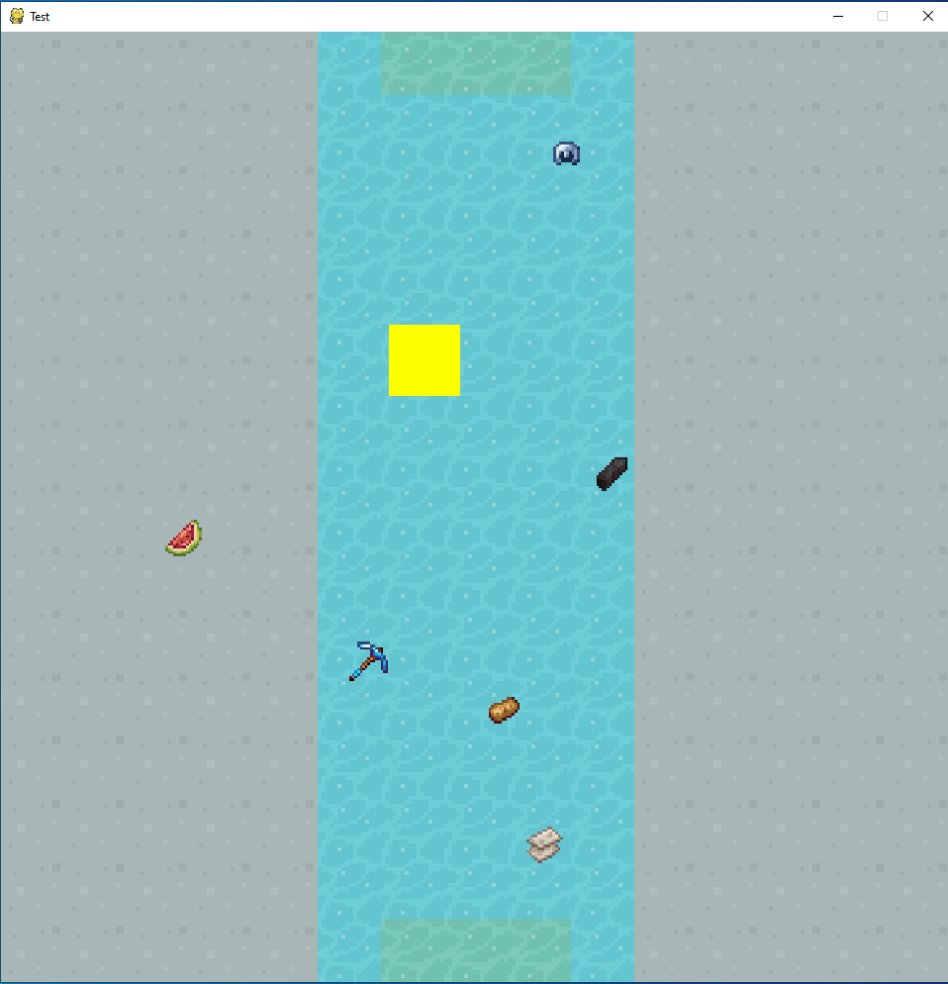

This solution does work, but not entirely. When colliding with a collision box, the player is taken to a new room, but their coordinates stay the same. For example, if I collided with a NORTH box at (50, 100), I would be taken to the room above, but I would still be at (50, 100). Since the collision boxes are at the same coordinates, I will now be colliding with the new room’s NORTH box at (50, 100) and so will go to the room above that and so on.

To solve this, when moving into a new room, I must change the player’s coordinates. To maintain collision, I will need to change the player’s rect’s X and Y coordinates. I would like the player to be positioned as close to the doorway they have “entered” from, without touching that doorway.

* When moving NORTH: X should be centred, Y should be 1 doorway height and 1 player height from window height
* When moving EAST: X should be 1 doorway width, Y should be centred
* When moving SOUTH: X should be centred, Y should be 1 doorway width
* When moving WEST: X should be 1 doorway width and 1 player width from window width, Y should be centred

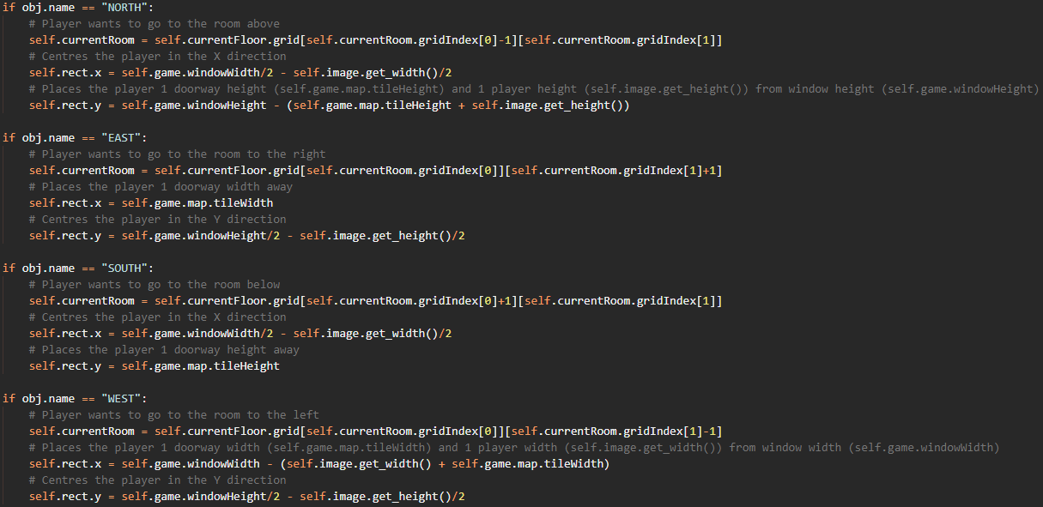

This fixes the issue. When moving rooms, the player gets placed right next to the doorway they just “entered” from:

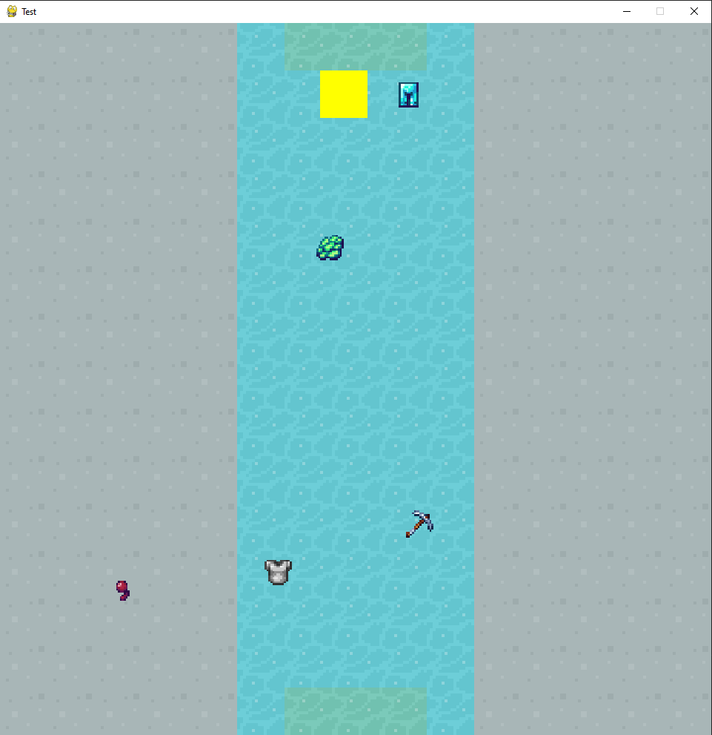

### ▮ Item Collisions

Since I do not have an inventory yet, I will just detect when the player clicks on an item, then I can add some functionality later. Again, since I used Rect’s for each item, collision detection should be quite simple. First, I need to get the position of the mouse;



Finally, I can use some list comprehension to find all the items in the itemDict whose Rects collide with the position of the mouse;



Now I can just loop through clickedItems and do whatever I want with them. For now, I’ll just make the item disappear, so I just need to remove it from the room dictionary;

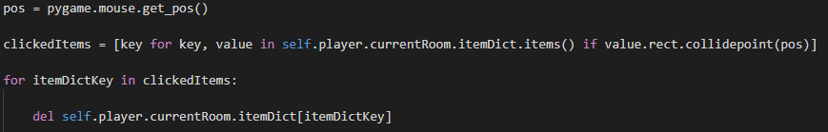

Which works, but like implementing player movement there are a couple of issues:

1. You do not actually have to click on the item, hovering over it will remove it.
2. You can pick up an item in the opposite corner of the room.

To ensure the user must click on the item, I need to detect when the mouse button has been lifted. Pygame has a built-in event for this so I can just add a simple if statement in;

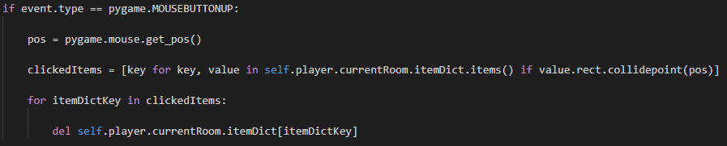

|  |  |  |  |
| --- | --- | --- | --- |
| Test | Expected Result | Actual Result | Pass or Fail |
| Hover over an item and see if it gets removed. | The item does not get removed if you hover over it. It should only get removed if you click on the item. | Hovering over the item does not remove it but clicking on it does. | Pass |

To solve the issue of being able to pick up items that are far away, I will first check to see if the player’s Rect collides with the item’s Rect before checking if the mouse collides with the item’s Rect. This way the player must be standing on or near the item to pick it up (as you would need to be in real life). To do this I will need to loop through all items in the room’s item dictionary. I’ll need to cast the dictionary to a list to be able to iterate over it;



Then I just need to check if each item’s Rect collides with the player’s Rect, then do all the other checks like mouse position etc;



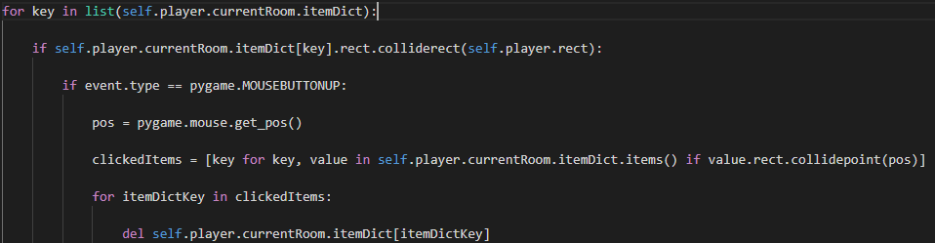

|  |  |  |  |
| --- | --- | --- | --- |
| Test | Expected Result | Actual Result | Pass or Fail |
| Try and pick up an item from across the room | The item does not get removed, but should get removed if you walk over it and click it | The item cannot be removed from across the room, but can once you walk over it | Pass |

## ▮ Updating player model

Eventually, I would like to update the player’s model to reflect the armour that they are wearing. This would be done by making a new image by combining the player’s base model with the images of the armour that they are wearing. For now, however, I will just change the player’s model to the item they have pick up, no matter if it is a piece of armour or not.

* Open the player’s base image
* Open the item’s image
* Paste the item’s image on to the player’s image
* Save this new image as a new modified player image
* Set the player’s image attribute to a new Pygame surface of this new image

This involves a lot of image processing. The best module for Python image processing is called *Pillow* (or PIL (Python Imaging Library)). The methods for opening, pasting, and saving images are quite low-level skill in Pillow so I do not need to familiarise myself with the module too extensively.

First, I will make an updatePlayerImage method in a separate file, updatePlayerImage.py. This method will have 2 parameters; “game” and “item”. Game is a reference to the Game object, and item is the item object whose image needs to be pasted onto the player’s image:

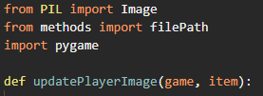

Now I need to open the player’s base image and the item’s image using Pillow. The PIL module includes an Image class that I can perform operations on:



Pasting the item’s image on to the player’s image is easy using the Image class:



Now I need to save this as a new image:



Last, I need to set the player’s image attribute to a Pygame surface object from this new image:



|  |  |  |  |
| --- | --- | --- | --- |
| Test | Expected Result | Actual Result | Pass or Fail |
| Pick up an item | The player should change from a yellow square to the item that was picked up | The player changes to the item | Pass |

Now I can add this method to when an item collision is detected:

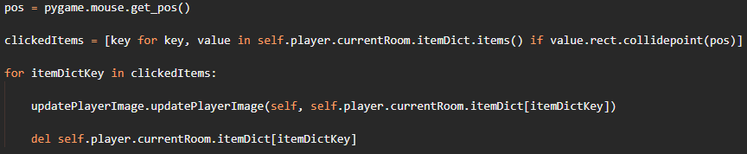

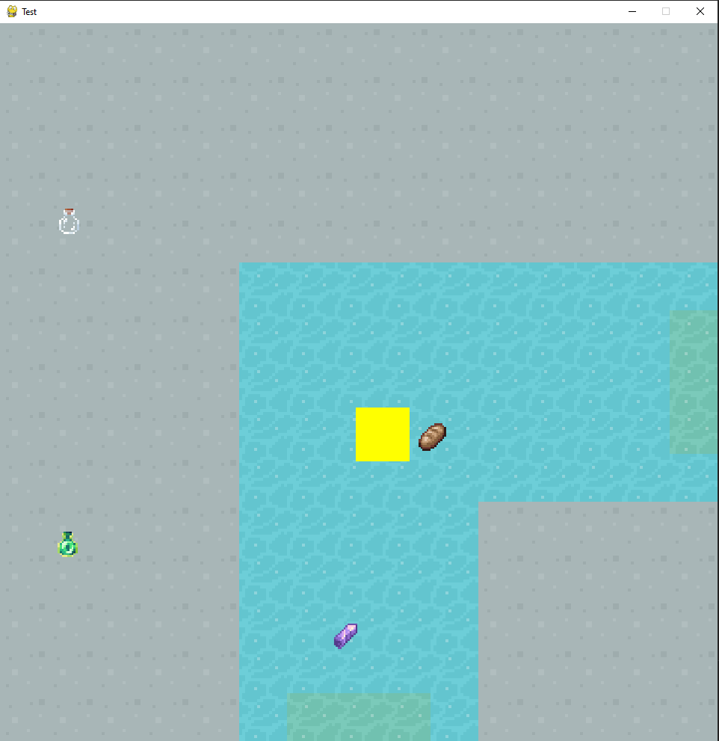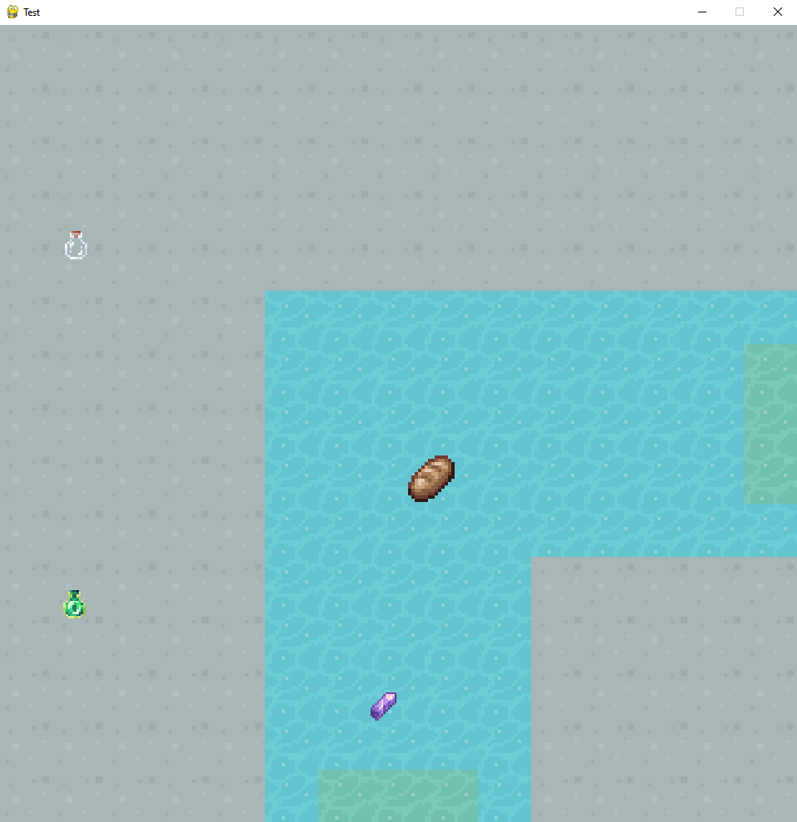

## ▮ Inventory

Currently, whenever an item is clicked on, a message is just output to the console. The game needs to add the item that the player has clicked on to the player’s inventory. The inventory itself will just be a list and adding to it will be rather simple. I will create an inventory class with the parameters “max” and “game”. Max will be an int representing how large the inventory is and game is a reference to the Game object:

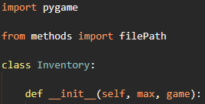

Now I just need to make a list variable to add items to, and a method to add given items to that list:

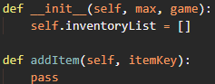

Since, when clicking on an item we loop through the room dictionary’s keys, we pass the addItem method a dictionary key, we need to access the room dictionary to obtain the actual Item object to add to the list:

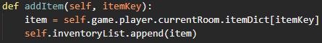

Finally, I need to make an inventory object an attribute of the player class. In the player class constructor method, I can add the line:



Then, when detecting whether an item is clicked on, before deleting the item object so it is removed from the screen, I need to call the addItem method on the player’s inventory object:

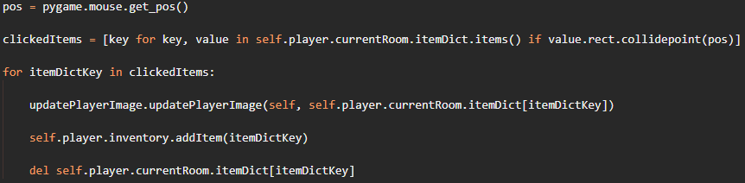

|  |  |  |  |
| --- | --- | --- | --- |
| Test | Expected Result | Actual Result | Pass or Fail |
| Click on an item | The item is removed from the screen, and added to the player’s inventory list | The item is removed from the screen, and added to the player’s inventory list | Pass |

|  |  |  |  |
| --- | --- | --- | --- |
| Test | Expected Result | Actual Result | Pass or Fail |
| Try and pick up 28 items | The player should be able to pick up 27 items, but nothing happens when clicking on the 28th | The player can pick up the 28th item | Fail |

I forgot to add the bit of input validation to check if the player’s inventory is full before adding an item to it. This was quite simple to implement:

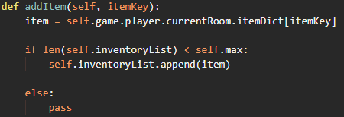

So far, the player can add items to their inventory, but they have no way of seeing what items they have in their inventory. I will use a separate scene when showing the inventory. To do this, I first need to add some if conditions in the main running loop where the updatePause() call is:

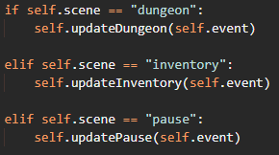

And I then need to make the updateInventory method:

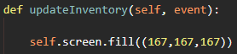

Finally, to make sure everything is working, I need a way of getting into the inventory scene. I will use the “E” key to do this:

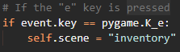

|  |  |  |  |
| --- | --- | --- | --- |
| Test | Expected Result | Actual Result | Pass or Fail |
| Press E while in the dungeon scene | Taken to the inventory scene, where it is a blank screen of colour (167, 167, 167) | Screen is filled grey | Pass |



Now, I can simply draw the items in the player’s inventory list to the screen, then rearrange them in a visually pleasing and manageable way.

To draw all the items to the screen, I need to iterate over the items in the inventory, then blit each item to the screen at some position. To start with, I can just blit all the items at (0, 0):

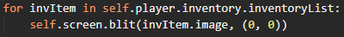

Leading to:



Now to add a visual inventory. Going into the inventory class, I can add an image and convert it to a pygame Surface to then blit onto the screen:

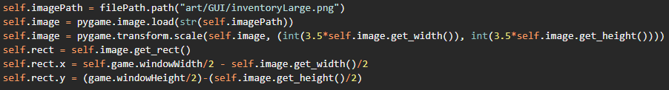

This code does several things that I have done on several classes before:

* Get a directory path to a file called inventoryLarge.png
* Create a pygame Surface from that directory path
* Scale that image up by 3.5x
* Create a pygame Rect object from that Surface
* Set the Rect object’s x and y coordinates to the centre of the page (so the image will be centred)

Going back to the updateInventory method, I can now blit this image:



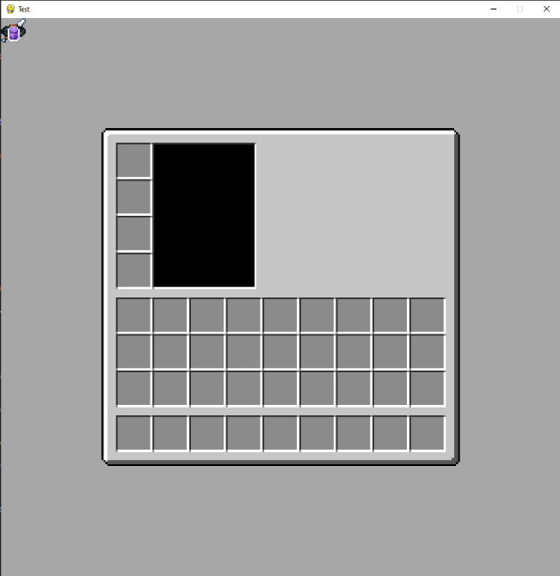

Finally, I can change where the items from the inventory blit to make them fit inside the inventory slots.

I would like the items to fill the inventory in a linear manner, that being the first 9 items will fill up the bottom row from left to right, the second 9 items to fill the second-from-bottom row from left to right and the final 9 items to fill the third-from-bottom row, again from left to right.

I now need to know the position of every item in the list, as well as the item itself. Python’s enumerate method allows me to keep track of index and value for every item in a list:



Now I can determine where each item should go:

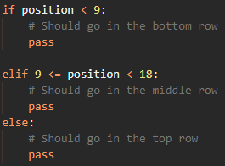

Finally, after a lot of trial and error for the right X and Y values (which is not a good practise to hard code in values, but the window size is unchangeable in this version of the game, so it is not too harmful), I got this code:

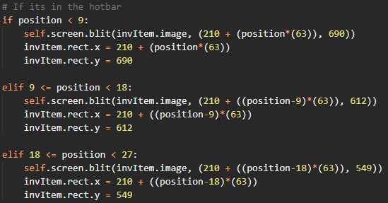

Then to fill in that black box, I will blit the player’s image (at an enlarged size). To make sure I do not make the player’s image larger while playing the actual game, I will make a reference to the player’s image:



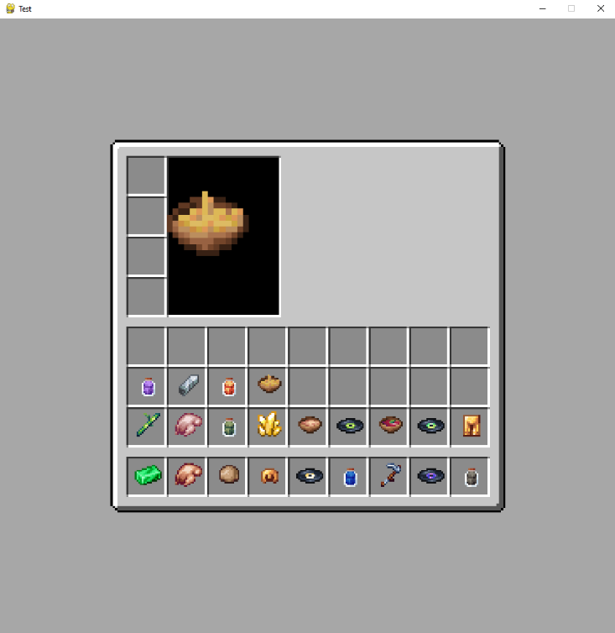

This is all the functionality that the player’s inventory needs.

## ▮ Enemies

Of course, wondering around a dungeon collecting items does not make for a very exciting gameplay experience. Creating enemies is like creating the player. There will be an enemy class (which will be a parent class to several enemy classes, like spiders and zombies etc.) which will inherit from the pygame Sprite class:

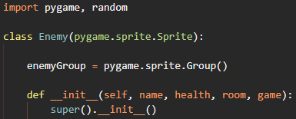

The line  creates a class variable, that will hold all the enemies in a Pygame sprite group, allowing me to easily access all the enemies when I am blitting them etc.

The parameters name and health are self-explanatory. The “room” parameter allows the enemy object to have a reference to the room that it is occupying. This way, each room will have a unique number of enemies and their movement can be handled individually. The “game” parameter allows the enemy object to have a reference to the actual game object.

Now I need to assign all the parameters to the object, and set up the enemy’s image and the enemy’s position in the room:

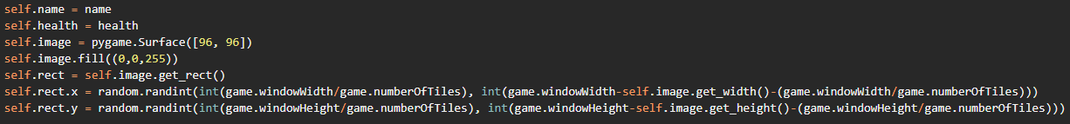

Now I just need to add the object to the class variable sprite group:



To test if my class is working as intended, I will just temporarily force create an enemy in the room that the player spawns in. In my main.py, where I create the player object and get the current room, I will create an enemy:

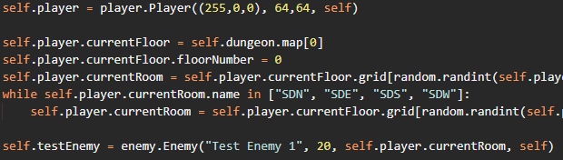

Then if I add to my updateDungeon method to draw the enemy, the enemy should appear in the room that the player spawns in:



|  |  |  |  |
| --- | --- | --- | --- |
| Test | Expected Result | Actual Result | Pass or Fail |
| There should be a blue square at a random position in the room that the player spawns in | There is a blue square at a random position | There is a blue square at a random position | Pass |

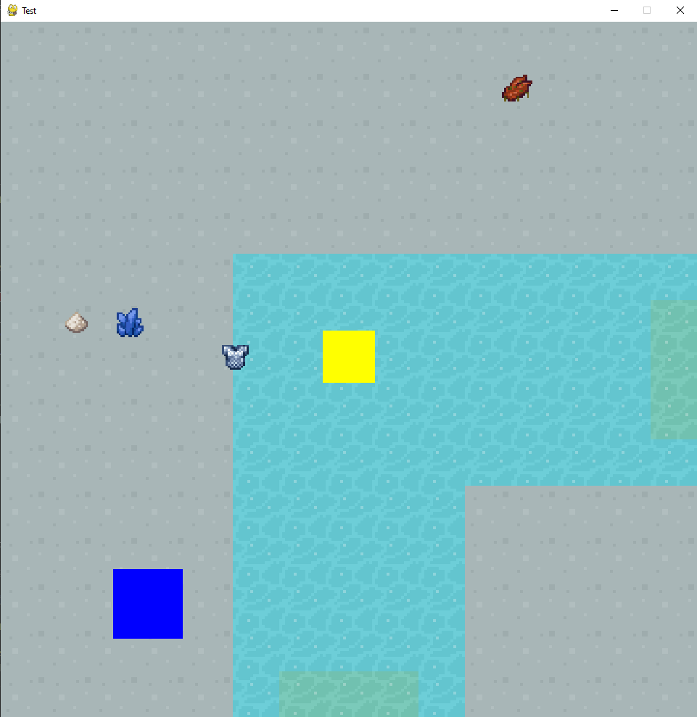

So, the enemy class is working, but the enemies currently only generate if they are hard-coded. I need to create a method to generate enemies in every room of every floor of a dungeon. I will make a generateEnemies file in my methods folder to hold this method.

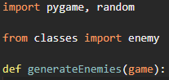

To access each room in the dungeon, I must iterate over the floors in the dungeon then the rooms in those floors. Since the rooms of a floor are held in a 2D-array, I will need to iterate over the “columns” and “rows” of the array:

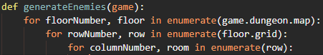

Every room needs to have the number of enemies inside of it calculated. To implement some progressing difficulty to the game, I will have more enemies generate the further down into the dungeon the player ventures, and since I have access to the floor number of the current floor (0-indexed), I can use this.

I would like to have it so the most likely option for the first floor (floor 0) is 0 enemies, since you may not have much gear and weapons and the player needs to have a chance to find their feet. I would like the second floor (floor 1) to have the most likely number of enemies be 1 and so on. But there should also be a chance for additional enemies on a floor. I will implement this probability as so:



This means there is a 5/9 chance for the room to have the same number of enemies as the room number (0 for first floor, 1 for second floor etc.), a 3/9 chance for the room to have 1 additional enemy, and a 1/9 chance to have 2 additional enemies.

Like how I added items to each room, I will implement a dictionary to hold every enemy for that room, then add numberOfEnemies number of enemies to that dictionary:

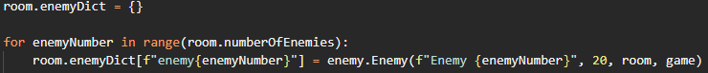

Now, instead of blitting the “testEnemy” object that I force-created, I need to iterate through the enemy dictionary of the room that the player is currently in, and then blit every enemy in that dictionary. Deleting the line where I blit the testEnemy object and replacing it with the code below should hopefully give 0-2 blue squares per room on the first floor of the dungeon.



|  |  |  |  |
| --- | --- | --- | --- |
| Test | Expected Result | Actual Result | Pass or Fail |
| Walk around and see if rooms generate with 0, 1 or 2 enemies | Rooms generate with 0, 1, 2 enemies | Rooms generate with 0, 1, 2 enemies | Pass |

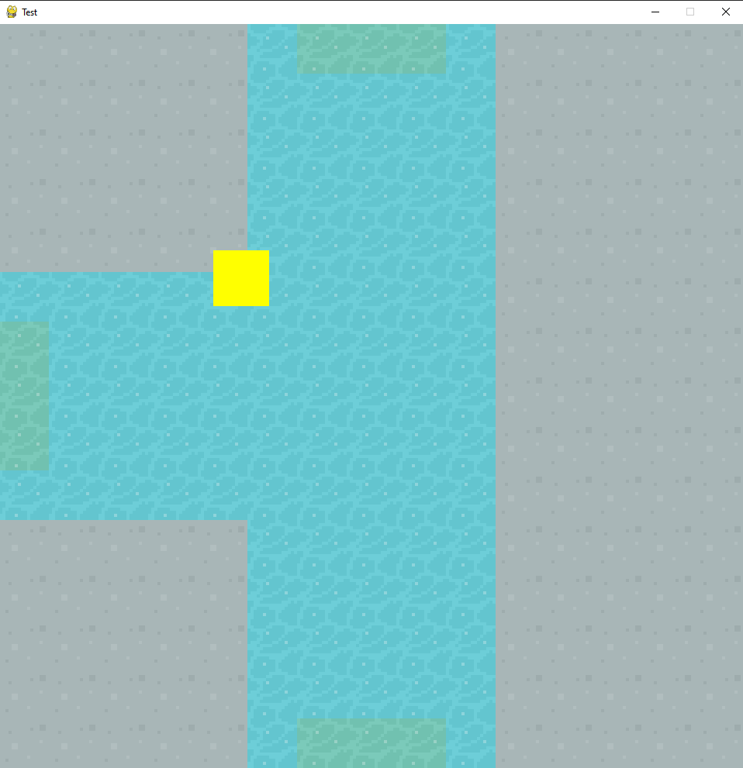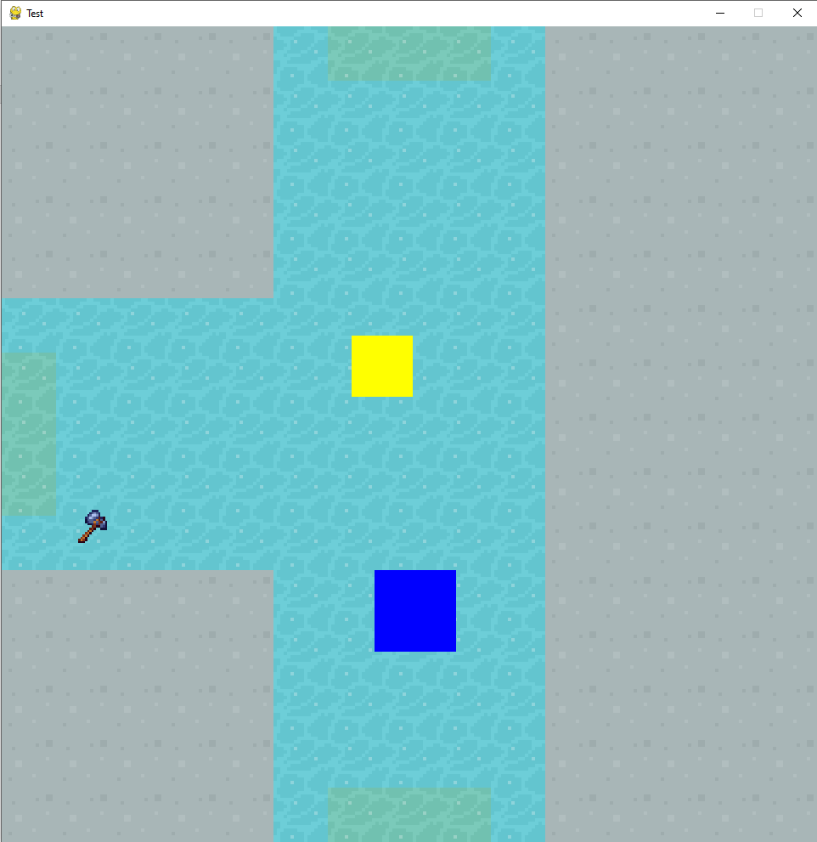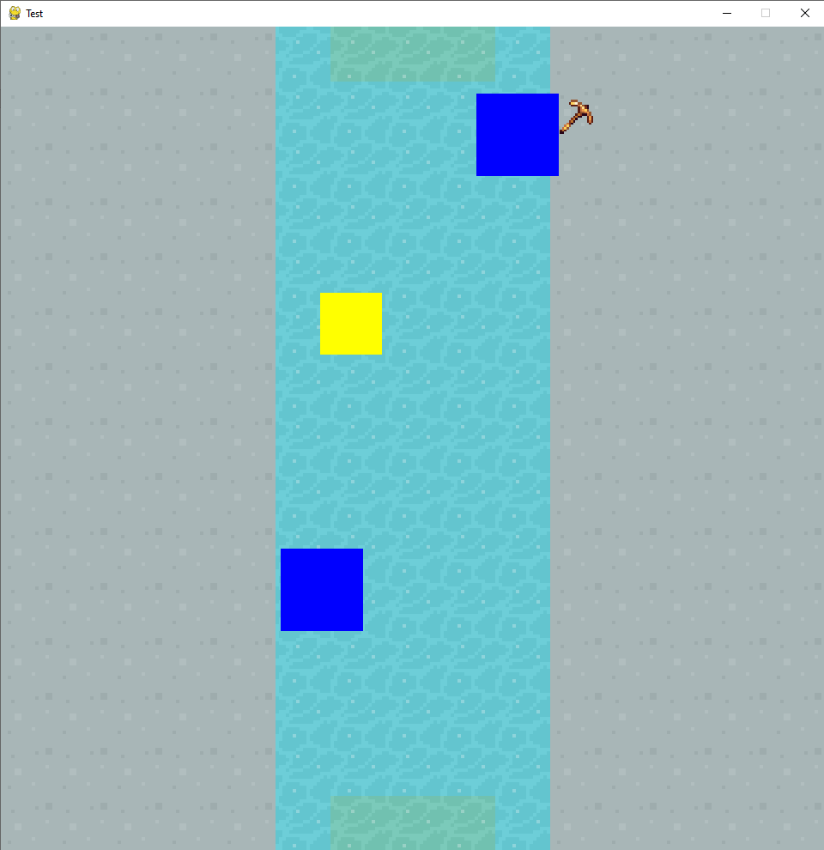

Now, I just need to implement collision between enemies and the player and enemy movement!

Adding collision is a very simple bit of code since Pygame handles all the complicated bits for me. Similar to how I detected if an item was clicked on, I can use the Pygame built-in colliderect() function to determine whether or not the player’s rect is colliding with an enemy’s rect. While we are iterating over every enemy in the current room, after I’ve blitted it to the screen, I can check if the player’s rect and that enemy’s rect are colliding:

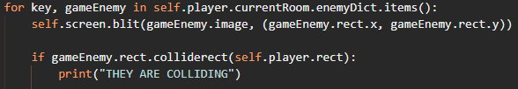

|  |  |  |  |
| --- | --- | --- | --- |
| Test | Expected Result | Actual Result | Pass or Fail |
| Walk into an enemy | The console should be spammed with “THEY ARE COLLIDING” if the player is on the enemy | The console is spammed with “THEY ARE COLLIDING” and stops when the player moves away | Pass |

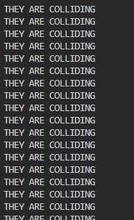

Finally, the enemies just need to move. I had no idea how to even approach this problem, so I did a bit of research and the KidsCanCode Youtube channel who I used to implement the Tiled map generation had another helpful video about enemy movement. The basic idea is that:

* Each enemy has its own personal timers
* Each enemy has a limit of how long it will move for (its “fitnessLimit”)
* That timer ticks at a different rate for each enemy (its “activity”)
* Once that timer hits a certain value, the enemy will move (its “stubbornness”)
* While the activity is higher than or equal to its stubbornness
  + Increase a new timer (its “laziness”)
  + Move the enemy
  + If the laziness is above the fitnessLimit, set activity and laziness to 0 and therefore break out of this while loop

So firstly, I need to create some of these timers and limits within the enemy class:

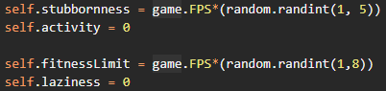

Since my game clocks ticks at game.FPS, multiplying it by a random number will lead to a random time in seconds. So, for every enemy, they will stay still for 1-5 between movements, and it will move for 1-8 seconds at a time. Next, I can make a move method that will be called every time the enemy is blit to the screen (in the updateDungeon method in the Game class):

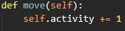

Secondly, I need to check if the activity has hit the stubbornness limit and that the enemy isn’t moving (i.e. activity < fitnessLimit):

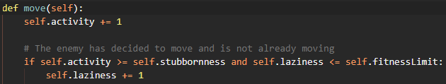

Finally, if the laziness is larger than the fitnessLimit, we need to reset activity and laziness, and if it isn’t then we can move the enemy:

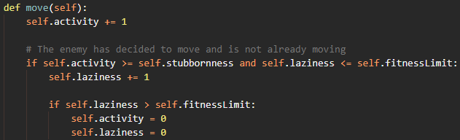

To move the enemy, I needed to go back to the KidsCanCode Youtube channel and see how they had implemented it. Again, another basic concept:

* The enemy needs to choose an X direction and a Y direction to move in (i.e. SW, NE, W, N etc.)
* If statements to determine how the enemy’s rect’s X and Y coordinates need to be altered
* Move the enemy’s rect to maintain collisions

To make sure that the direction that the enemy is moving in is not constantly changing, I will choose a direction to move at the exact moment when laziness is equal to the stubbornness and the enemy isn’t already moving:

  
  
Secondly, we need to determine which way the enemy is moving and then move the enemy’s rect:

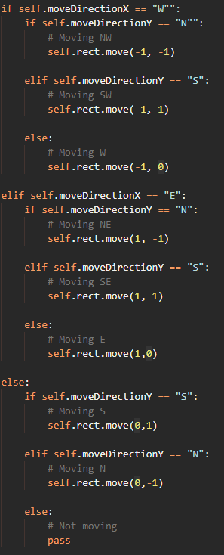

Finally, I just need to add the move method to where the enemy is blitted to the screen, and test if it works:

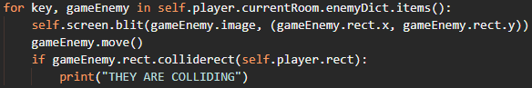

|  |  |  |  |
| --- | --- | --- | --- |
| Test | Expected Result | Actual Result | Pass or Fail |
| See if enemies move | Enemies should move at different times in different directions | The enemies do not move at all | Fail |

After research this issue for a while, I decided to take another look at the Pygame documentation, and saw that there are 2 different move methods that can be done on a rect object; rect.move and rect.move_ip. I decided to try using move_ip (move in place) as opposed to simply moving the rect. There was also a typo involving double speech marks around the “W” and “N” moveDirections that I fixed:

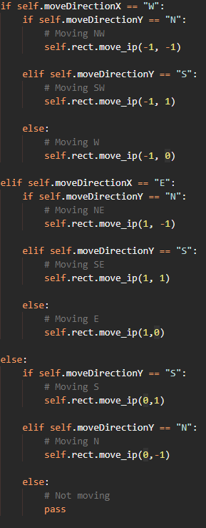

|  |  |  |  |
| --- | --- | --- | --- |
| Test | Expected Result | Actual Result | Pass or Fail |
| See if enemies move | Enemies should move at different times in different directions | Enemies do move at random intervals, and collisions are preserved | Pass |

At first, I did not understand why the move_ip method worked but the move method did not. However, after doing some research I found this [Stack Overflow](https://stackoverflow.com/questions/61578694/difference-between-rect-move-and-rect-move-ip-in-pygame) page. To summarise, rect.move returns a new Rect object at the position that the original rect would be moved, whereas rect.move_ip moves the existing Rect object’s x and y attributes.

Finally, I need to do a bit of input validation, by making sure that the enemy cannot move if it is going to move off the screen:

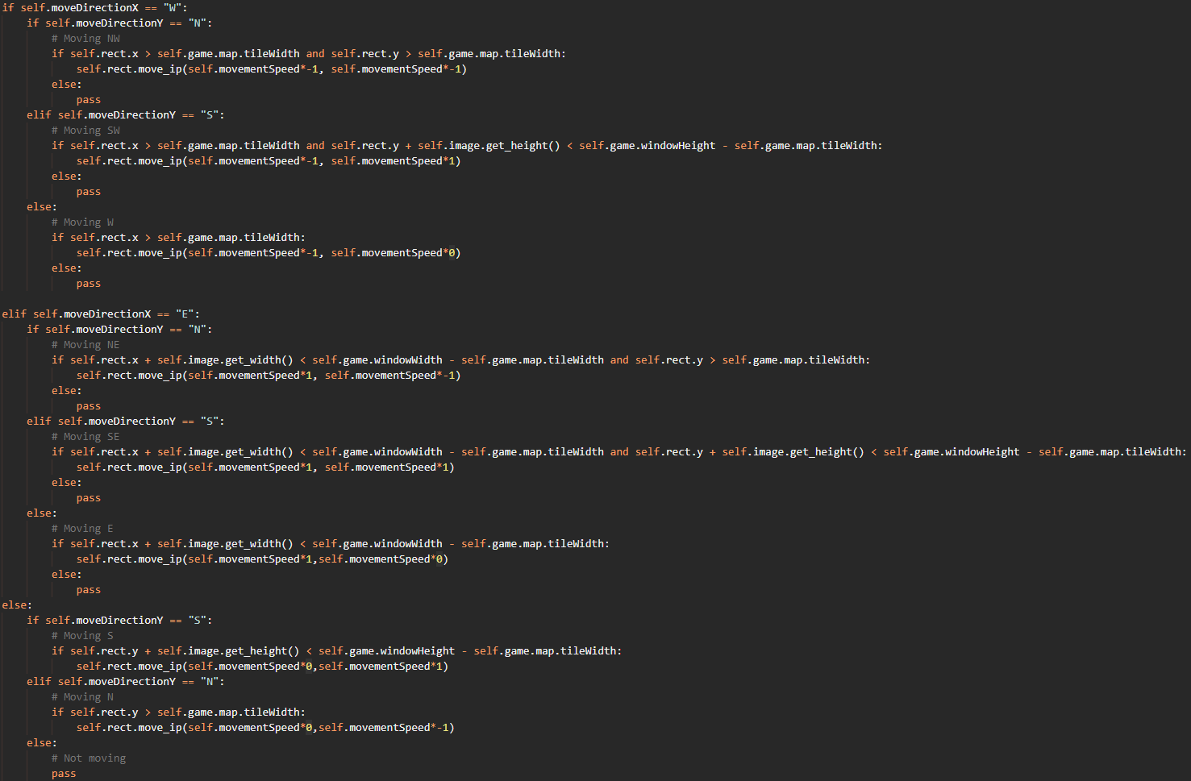

For now, this is all that an enemy needs to do.

## ▮ Intermission

This was always going to be an ambitious project to complete. While the time frame was plenty large enough for a professional development team to complete in, working on this on the side along with 3 A-Level courses is difficult. Due to time constraints, I have decided to prioritise a few aspects of my game that I will be able to complete well and not include other aspects that I will not be able to program to a standard that I think is suitable.

### ▮ Graphics and sound

While graphics and sound effects are some of the most important things to the user, the game is technically functional without them. I have made it easy for myself to implement sprite sheets etc. by referencing external files, and by initialising the Pygame mixer. However, since they are non-essential, I will not be implementing graphics or sound effects.

### ▮ Complete saving and loading

Saving and loading is clearly an essential part of the game. However, it must be done properly to avoid corruption upon saving / loading your game. I will not be able to completely implement saving and loading of my game, but I will implement partial saving and loading. I will be able to save the player’s inventory and the items inside of it and load it again, allowing the player to keep their most important progress, but get a fresh new dungeon to play, while also saving myself time.

### ▮Enemy attacks

Currently, enemies simply move around the screen and interact with the player once they have collided. Since the enemies have no way of fighting back against the player, enemies are more annoying than fearful at this point. I will implement a turn-based attack system (simple to other RPG games like the Pokémon franchise). This will enable the risk-reward aspect of my game that players find very compelling.

### ▮Bosses / End state

My game must have an end point. This will be the boss on the final floor of the dungeon. This boss will most likely inherit from the enemy class since it will share a large amount of attributes, methods, and functionality. This boss will also act as the end-state of my game, giving players a sense of achievement.

### ▮Status bars

Currently, there is no “survival” aspect to my game, the player is a more of a tourist rather than an adventurer. The status bars such as health and hunger will provide more risk that the player will need to manage.

I will hopefully reflect on these decisions in my final evaluation.

## ▮ Inventory saving and loading

As previously mentioned, saving, and loading of the entire game is not possible to implement in my timeframe to a suitable standard. However, saving the items inside the players inventory and loading them again is possible.

As I mentioned in my design section, I will use the pickle module to save the player’s inventory. While a list object can be saved in other forms, since the list that acts as the player’s inventory contains objects, it must be pickled to keep those objects acting as objects, rather than strings.

To begin, I will create a separate file called saveGame.py with a save function to handle the saving of inventories:

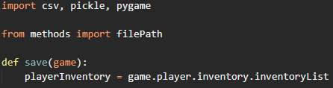

Next, I just need to pickle the variable “playerInventory” using the pickle module:



This line of code creates a new file called “inventory.p” (a Python Pickle file) and pickles the variable playerInventory inside of that file.

For now, I will make the game automatically save the inventory whenever the game is paused. I just need to call the save function where the game scene is changed to the pause scene:

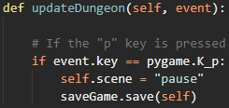

|  |  |  |  |
| --- | --- | --- | --- |
| Test | Expected Result | Actual Result | Pass or Fail |
| Collect some items, then pause the game to save | An inventory.p file is created in the root directory | A TypeError is raised | Fail |



I did some research about this error and came across a different part of the pickle documentation, where there was a section titled “What can be pickled?”:

$$Generally, you can pickle any object if you can pickle every attribute of that object.$$

Going through every attribute of the item class (the objects that are in the inventoryList that I’m trying to pickle), there are only 2 attributes that have anything to do with the pygame.Surface class; self.game and self.image:



To save the player’s inventory, I need a way of saving certain aspects of each item, then “rebuilding” each item object when I load:

* When saving the player’s inventory, loop through every item in the inventory
* Set that item’s .game and .image attributes to None (in order to be able to use pickle)
* Save the item to a pickle file
* When loading the inventory, loop through the un-pickled list
* For every item, re-set it’s .game and .image attributes
* Set the player’s inventory list to the un-pickled list

First, I need to iterate through every item in the player’s inventory, and set their .game and .image attributes to None:

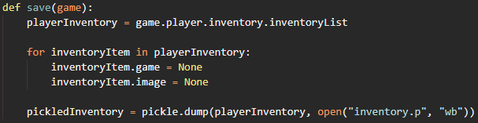

|  |  |  |  |
| --- | --- | --- | --- |
| Test | Expected Result | Actual Result | Pass or Fail |
| Collect some items, then pause the game to save | An inventory.p file is created in the root directory | An inventory.p file is created in the root directory | Pass |

Now the pickle module can completely pickle the inventory list. However, after pausing (and saving) and heading back to the game, trying to open the inventory results in another TypeError:

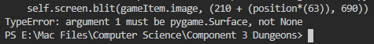

This error message shows that a None object is trying to be blitted on to the screen. This confused me for a while, as I was not editing the values of the player’s inventory directly, I made a temporary copy of the list then edited that. However, I then came across [this Stack Overflow](https://stackoverflow.com/questions/3975376/understanding-dict-copy-shallow-or-deep/3975388#3975388) page which included this image explaining how referencing an object works in Python:

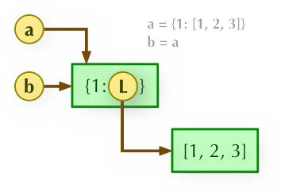

In the line of my code:



playerInventory can be thought of as “b” and game.player.inventory.inventoryList (i.e. the list of items in the player’s inventory) can be thought of as “a”.

So, when I was changing the values in “b”, I was also changing the values in “a” (i.e. which is what the rest of my code references when blitting items) as they both reference the same data in memory. On the same Stack Overflow page, there was reference to a “copy” module that could prevent my issue by making two completely isolated variables instead of having 2 pointers pointing to 1 set of data in memory, by using a method called deepcopy():

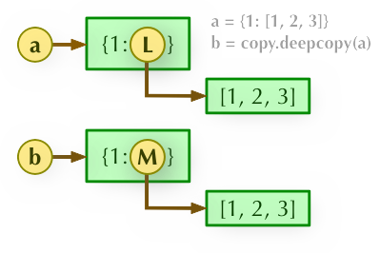

However, this deepcopy method actually uses the pickle method, which won’t work on the .game and .image attributes as I discussed earlier so this isn’t applicable. Instead, I will need to do a few things to change the values of items in the playerInventory list, but not the original player.inventory.inventoryList list:

* Loop through every item in the inventory
* Create a new item using each item’s attributes
* Add the newly created item (which will be a different location in memory) to a new list
* Pickle that new list

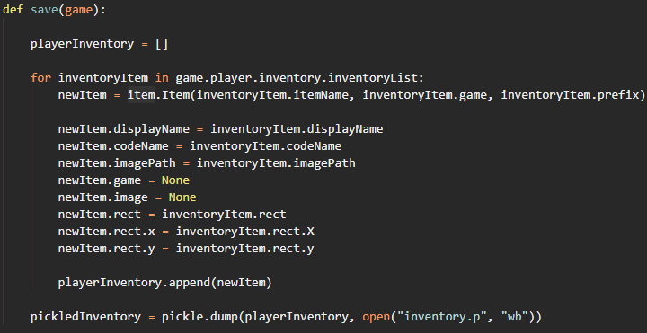

|  |  |  |  |
| --- | --- | --- | --- |
| Test | Expected Result | Actual Result | Pass or Fail |
| Collect some items, then pause the game to save | An inventory.p file is created in the root directory | An inventory.p file is created in the root directory | Pass |

|  |  |  |  |
| --- | --- | --- | --- |
| Test | Expected Result | Actual Result | Pass or Fail |
| Open inventory again after saving | No crashes, inventory should open just fine | No crashes, inventory should open just fine | Pass |

Now that saving the inventory is working correctly, I can begin working on loading a saved inventory file.

As I mentioned in my bullet-point list above, to load a file I first need to unpickle the inventory file, then loop through every item and “re-set” the .game and .image attributes.

First, to unpickle the inventory file:



Secondly, I need to loop through the items in the list, and “re-set” the attributes. Since the .game attribute is jus a reference to the Game object, and since the Game object is a parameter of the load method, I can simply set the .game attribute to the game parameter.

But for the .image attribute, since it is created using the .ima gePath attribute (which could be pickled, so will still be available) it can be re-created using the .imagePath attribute:



Next, I need to set the player’s inventory list to this new list:



Finally, I need to add a way to load the saved inventory. For now, I will just make the “L” key the load key:

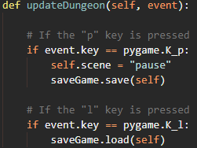

|  |  |  |  |
| --- | --- | --- | --- |
| Test | Expected Result | Actual Result | Pass or Fail |
| Collect items, save the inventory, collect more items, load the saved inventory | When the saved inventory is loaded, the items collected after the inventory was | Only the items that were in the inventory at the point of save are loaded again | Pass |

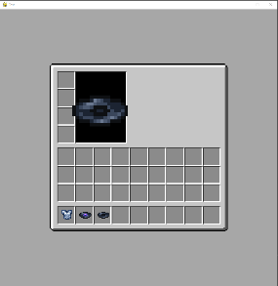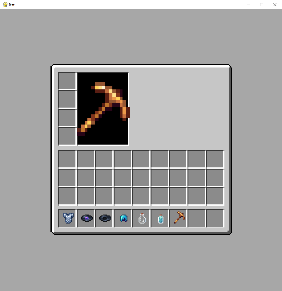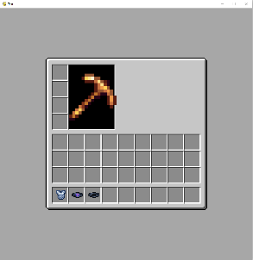

## ▮ Enemy attacks

As I mentioned in my intermission, currently, enemies only wander around; they must pose some risk. When the player encounters an enemy, they should enter a “fight” scene. Like how I implemented the inventory scene, I will set the scene to “fight” when the player collides with an enemy, detect if the scene is the “fight” scene, then call a method handling everything whilst the player is in the “fight” scene:

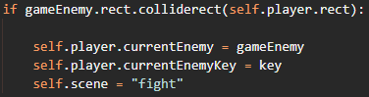

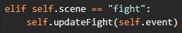

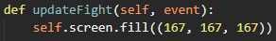

|  |  |  |  |
| --- | --- | --- | --- |
| Test | Expected Result | Actual Result | Pass or Fail |
| Collide with enemy | The screen is filled with grey colour (i.e. scene is set to “fight”) | The screen is filled with grey colour | Pass |



I will be using a turn-based attack system, like the Pokémon games. Furthermore, I will be positioning the player and the enemy in a similar way to Pokémon as well.

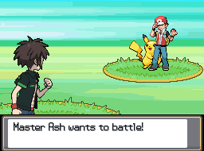

First, I need to get the player’s image, enlarge it, then blit it in the bottom left-ish corner of the screen:



|  |  |  |  |
| --- | --- | --- | --- |
| Test | Expected Result | Actual Result | Pass or Fail |
| Collide with enemy before picking up any items | The player (a yellow box) is displayed on the screen | A yellow box is displayed on the screen | Pass |

|  |  |  |  |
| --- | --- | --- | --- |
| Test | Expected Result | Actual Result | Pass or Fail |
| Collide with enemy after picking up an item (and changing the player model) | The player (an item) is displayed on the screen | A yellow box is displayed on the screen | Fail |

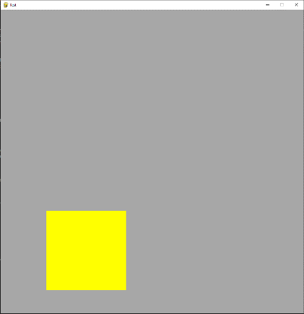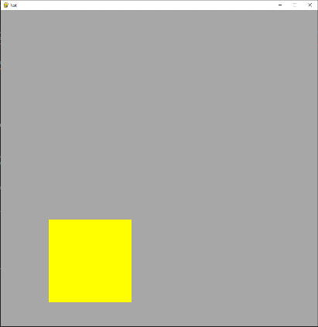

This is because I referenced the player’s base image, rather than the constantly updating image attribute that is edited by the updatePlayerImage method:



|  |  |  |  |
| --- | --- | --- | --- |
| Test | Expected Result | Actual Result | Pass or Fail |
| Collide with enemy before picking up any items | The player (a yellow box) is displayed on the screen | A yellow box is displayed on the screen | Pass |

|  |  |  |  |
| --- | --- | --- | --- |
| Test | Expected Result | Actual Result | Pass or Fail |
| Collide with enemy after picking up an item (and changing the player model) | The player (an item) is displayed on the screen | The corresponding item is displayed on the screen | Pass |

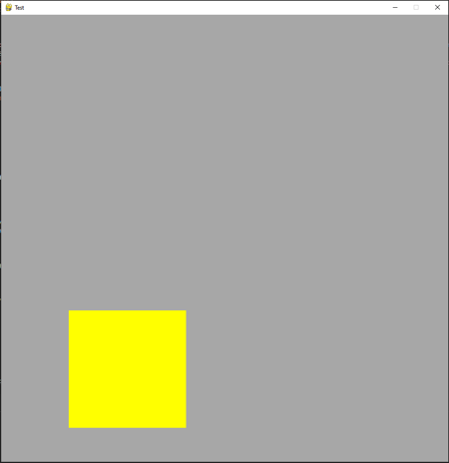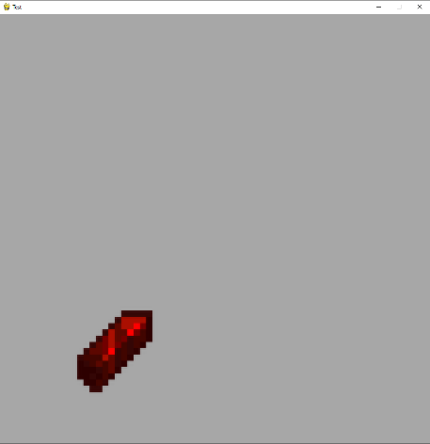

Now, I need to blit the enemy’s image in the top right-ish. When the player collided with the enemy, I set the enemy object as one of the player’s attributes, currentEnemy. I can reference that attribute to access all attributes of the enemy, including its image:



|  |  |  |  |
| --- | --- | --- | --- |
| Test | Expected Result | Actual Result | Pass or Fail |
| Collide with enemy | The player is displayed bottom left, the enemy is displayed top right | The player is displayed bottom left, the enemy is displayed top right | Pass |

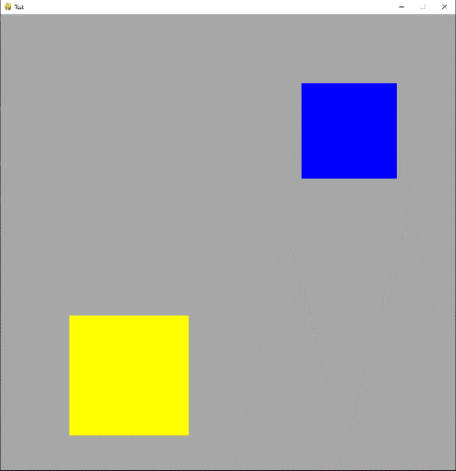

Now I can implement some fighting. Since there are only 2 possible options (player’s turn or enemy’s turn) and it needs to alternate between the two, I can keep a running total and check if it is even or not. When I create the game, I can make a variable to keep track of whose turn it is:



Then in the updateFight method, I can check if this variable is even. If it is even, it is the player’s turn, if it is odd, it is the enemy’s turn:

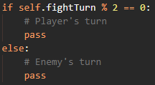

The player needs to be able to access their inventory if they need to eat some food to regenerate health or use a weapon against the enemy. Thankfully, I should be able to just change the scene from “fight” to “inventory” when it is the player’s turn, and they press “E”:

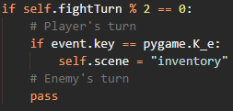

Now, a few things need to be sorted out:

* Determine what kind of item is clicked on (weapon, food, armor etc.)
* Return to the fight scene once the item has been used

Currently, the program has no way of determining what scene to jump back to after the inventory is no longer needed. A good way to solve this would be to keep track of the previous scene whenever I change the scene, then set the scene to the previous scene after current scene is no longer needed.

To accomplish this, wherever I update self.scene, I need add the line below *before* changing the scene:



Now the player’s turn code looks like this:

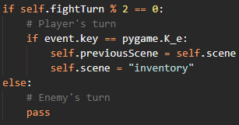

This helps to accomplish that second bullet point but determining what kind of item is clicked is much more intricate.

### ▮ Item classification

Currently, all items are of the Item class. This is useful for making loads of items that all do the same thing, however different items behave differently. Weapons need to be able to do damage to enemies, food needs to be able to heal the player, armour needs to be able to decrease the damage taken etc.

To do this, I need to make several classes that inherit from the Item class:

* Armor – Needs to be able to decrease damage taken by the player (I use the American spelling here because, if I were to open-source this project, it is standard to use American spellings, like color etc.)
* Weapon – Needs to be able to do damage to an enemy
* Music Discs – Needs to be able to change the current music of the game (Not going to be included, but should be included if the game was to ever be published / completed)
* Food – Needs to be able to heal the player
* Potion – Needs to be able to give certain effects to the player (Also will not be implemented)
* Valuable – Needs to be traded for other items (Again, not going to be implemented, but could be in the future)
* Misc – Items that do not fit in any of the categories above

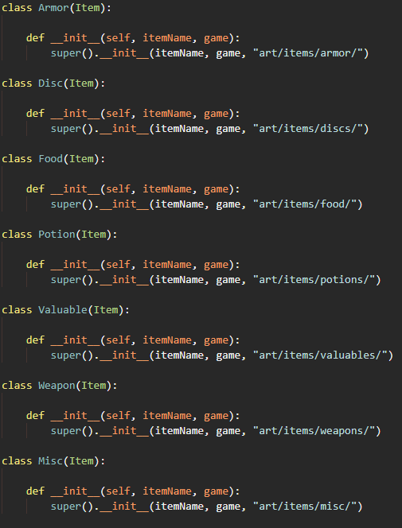

To implement these different types of items into the game, I need to change how items are generated. Inside my generateItems file, I picked a random prefix for each item, but I just made a generic Item object. Below is the code currently:





Instead of creating generic Item objects, I need to create specific classes depending on the value of category:

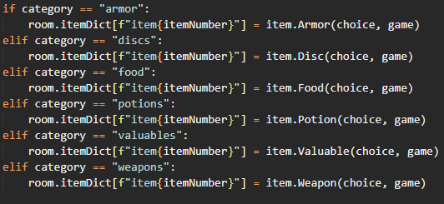

|  |  |  |  |
| --- | --- | --- | --- |
| Test | Expected Result | Actual Result | Pass or Fail |
| Play the game | The game should behave as before, item behaviour should be unchanged in every aspect | Item behaviour and game behaviour is the same as before | Pass |

Finally, I can make some variables in the Weapons, Armor and Food classes. These variables will reflect how much damage, damage protection and hunger each item has:

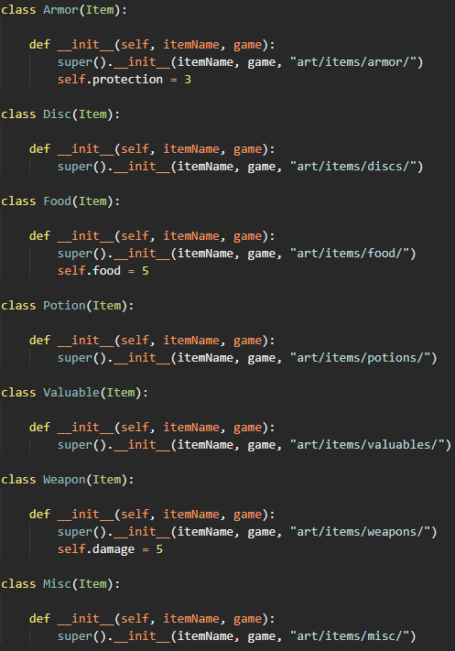

These stats would be unique to each item (randomly generated on instantiation), but for now I will just have them at these values.

Now, I can determine what kind of items are clicked on in the inventory.

In my updateInventory method, I need to do some click detection. This is going to be very similar to how I implemented click detection in the dungeon scene.

* Loop through all the items in the player’s inventory
* If the mouse is colliding with an item’s rect
* If the mouse button is clicked down
* Determine what type the item is

Since I already loop through all items in the player’s inventory when I am blitting them, I can get the mouse’s position, and check if the mouse is colliding with an item:

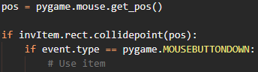

First, the Weapon item. If the item that was clicked off is a weapon, we need to do damage to the enemy. However, we can only do damage if the previous scene was a fight. This is because the player could access their inventory outside of the fight and click on a weapon which would result in an error since there is no current enemy to do damage against. To determine the type of an object, Python has a type() method:



I can then do damage to the current enemy, hand the turn to the enemy (i.e. increment fightTurn) and go back to the previous scene:

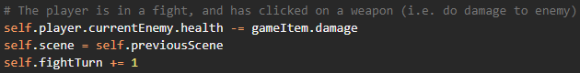

|  |  |  |  |
| --- | --- | --- | --- |
| Test | Expected Result | Actual Result | Pass or Fail |
| Use a weapon | The enemy’s health should decrease, and return to the fight scene | The enemy’s health does decrease and is returned to the fight scene | Pass |

Second, the Food item. Food should be able to be eaten at any time, not just if the player is in a fight. If the item is a food item, we need to increment the player’s health, remove the item from the inventory (since the player has “eaten” it), go back to the previous scene and let the enemy have its turn:

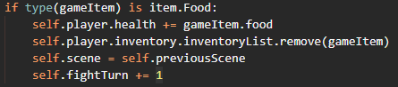

|  |  |  |  |
| --- | --- | --- | --- |
| Test | Expected Result | Actual Result | Pass or Fail |
| Eat some food during a fight | The player’s health should increase and return to the fight scene | The player’s health does increase and is returned to the fight scene | Pass |

And finally, an armor item. This one is slightly more complex. Below is how I would like the armor items to work:

* If the player clicks on an armor item, add the item’s protection to the player’s total protection then remove the item
* Use an equation to determine the protection factor (Should be < 1 since we want to decrease incoming damage)
* Multiply the enemy’s damage by the protection factor
* Set the player’s total protection to 0 after the enemy is dead

The player’s total protection should start at 0, so I need to add the below line to the player class constructor method:



Now I can add the armor’s protection to the player’s protection, remove the armor item from the inventory, return to the previous scene and switch to the enemy’s turn:

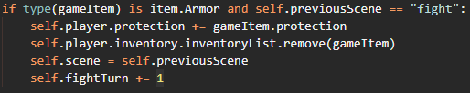

|  |  |  |  |
| --- | --- | --- | --- |
| Test | Expected Result | Actual Result | Pass or Fail |
| Try and open inventory while in a fight | The scene changes from fight to inventory, and the inventory contains all the items it should | The scene changes from fight to inventory, and the inventory contains all the items it should | Pass |

Going back to the updateFight() method, I can now implement the enemy’s turn. The enemy needs its own damage attribute, so I need to add a damage attribute in the enemy class constructor method:



Now, I just need to decrement the player’s health by the enemy’s damage; but I need to include the protection factor.

In the player class, I will make a new method to calculate the protection factor using a formula:



The equation that I will be using is:

$$F_{P}=-\left(P_{T}-\frac{5}{2}{P_{T}}^{\frac{-1}{2}}\right)•\frac{1}{P_{T}}+1$$

Where FP is the protection factor and PT is the total protection. The equation’s graph is below:

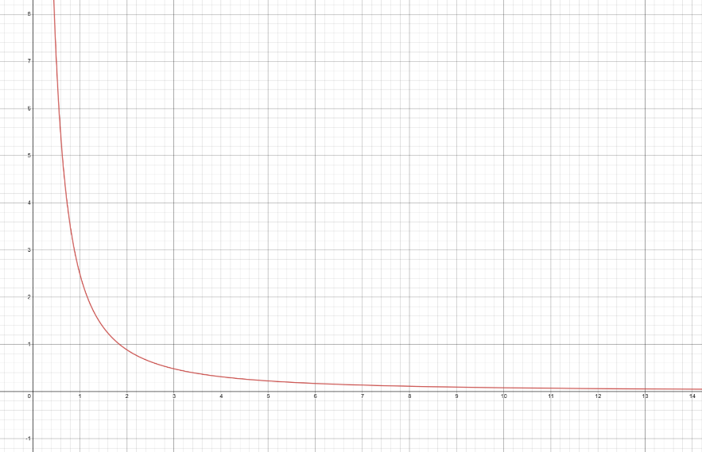

This equation is only suitable for PT values above or equal to 2. In the calculateProtection method, I need a special case for if PT is < 2, then substitute PT into the equation otherwise:

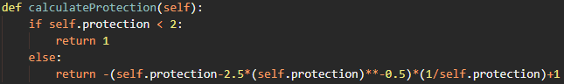

In the enemy’s turn:



And finally, I need to increment fightTurn so it goes back to the player’s turn:



|  |  |  |  |
| --- | --- | --- | --- |
| Test | Expected Result | Actual Result | Pass or Fail |
| Equip some armour, and check if the enemy’s damage changes | The enemy’s damage should decrease | The enemy’s damage decreases to 0 | Fail |

This is because using int() rounds the number down. To keep the enemy’s damage value non-zero, I will round the result of calculateProtection to 2 decimal places, then also round the player’s health to 2 decimal places:



|  |  |  |  |
| --- | --- | --- | --- |
| Test | Expected Result | Actual Result | Pass or Fail |
| Equip some armour, and check if the enemy’s damage changes | The enemy’s damage should decrease | The enemy’s damage decreases to a non-zero value | Pass |

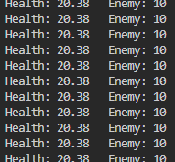

Now that the attack logic is coded, all that is left to do is some logic to determine if the enemy (or player for that matter) has died:

* If the enemy’s health is 0 or less
* Set previous scene to the current scene
* Set the current scene to dungeon
* Delete the enemy from the room’s enemy dictionary
* Set the fight turn to 0 (so the player will go first in the next fight)
* Set the player’s protection to 0 (so the player cannot continuously apply armor)
* If the player’s health is 0 or less
* Set previous scene to the current scene
* Set the current scene to “gameover”

The enemy’s death logic:

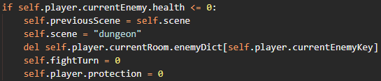

The player’s death logic:

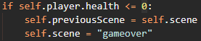

|  |  |  |  |
| --- | --- | --- | --- |
| Test | Expected Result | Actual Result | Pass or Fail |
| Kill the enemy | The player should be returned to the dungeon scene | The player is returned to the dungeon scene | Pass |

|  |  |  |  |
| --- | --- | --- | --- |
| Test | Expected Result | Actual Result | Pass or Fail |
| Die from the enemy | The player goes to the game over scene | Nothing happens | Fail |

I forgot to implement the logic for the game over scene. Where I implement all the other scenes I can add:

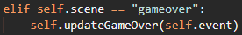

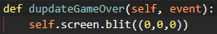

|  |  |  |  |
| --- | --- | --- | --- |
| Test | Expected Result | Actual Result | Pass or Fail |
| Die from the enemy | The player goes to the game over scene | The player goes to the game over scene | Pass |



Lastly, if the player encounters an enemy without a weapon, currently there is no way to escape. I will add a fist button that will do 1 damage to the enemy that will be always available.

In the inventory class, I will create a fist button Surface along with a Rect object:



Now in the updateInventory method, if the previous scene was a fight scene, I need to blit the fist button at its rect’s position:



Secondly, I need to check if the player clicks on the button. Again, like how item click detection works, I need to see if the mouse’s position collides with the rect, and if the mouse button is being pressed down:



Finally, I need to decrease the enemy’s health by 1, go back to the previous scene, and hand the fight turn over to the enemy:

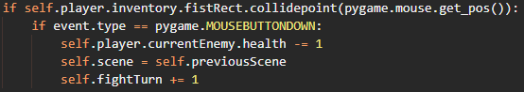

|  |  |  |  |
| --- | --- | --- | --- |
| Test | Expected Result | Actual Result | Pass or Fail |
| Encounter an enemy and attack them with a fist | The enemy’s health goes down by 1 | The enemy’s health goes down by 1 | Pass |

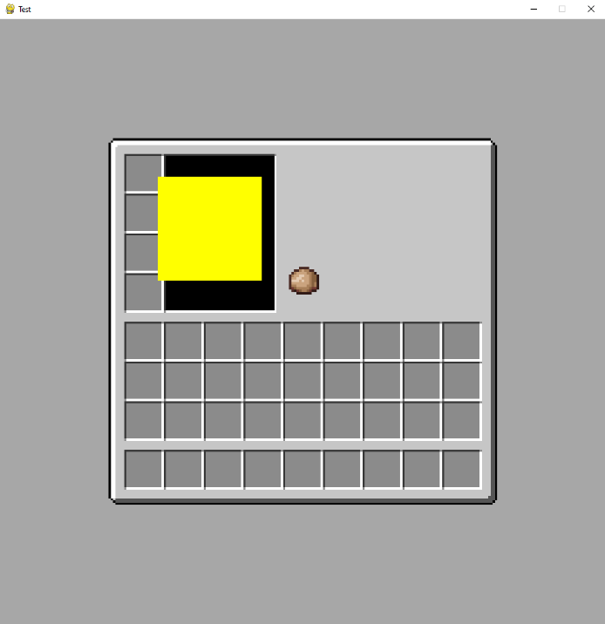

The player has a way of fighting enemies, and the enemies have a way of fighting back

## ▮ Text boxes

While there is a lot of working functionality in my game now, a lot of it happens with no indication to the user. For example, when you equip some armour, there should be a text box letting you know that the armour was equipped.

To do this, I need a way of showing any text on the screen. I will do this using a Text Box class. This class will take parameters of the size, colour, and words of the text to display, and have a method to blit the text onto a given surface.

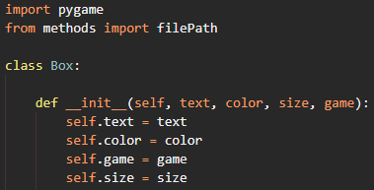

In Pygame, to draw any text on a surface, it needs to be created using a Font object. A font object can be created by referencing a font file and a size. To match the pixel style of my game, I chose the [Press Start 2P](https://fonts.google.com/specimen/Press+Start+2P?query=2P) font:

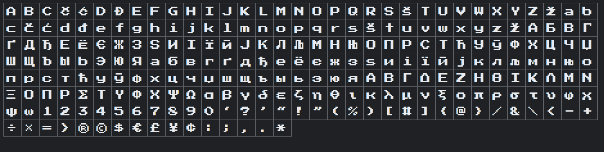

And created a Pygame font object:



To create a blit-able surface, you need to “render” the font. The “True” in the code below means that the text should use antialiasing:



Finally, I can make a method called draw to blit the text on to a surface:

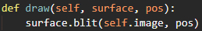

Now, when I create the game, I can make a Box object:



Then in the updateDungeon method, I can call the draw method of the box object:



|  |  |  |  |
| --- | --- | --- | --- |
| Test | Expected Result | Actual Result | Pass or Fail |
| Run the game | There should be some red Hello World! Text in the top left in the Press Start 2P font | There is no text | Fail |

Pygame blits font objects last, and I put that draw statement before drawing the map, player etc. Placing the draw statement *after* blitting the map and other aspects results in the text showing

|  |  |  |  |
| --- | --- | --- | --- |
| Test | Expected Result | Actual Result | Pass or Fail |
| Run the game | There should be some red Hello World! Text in the top left in the Press Start 2P font | There is text | Pass |

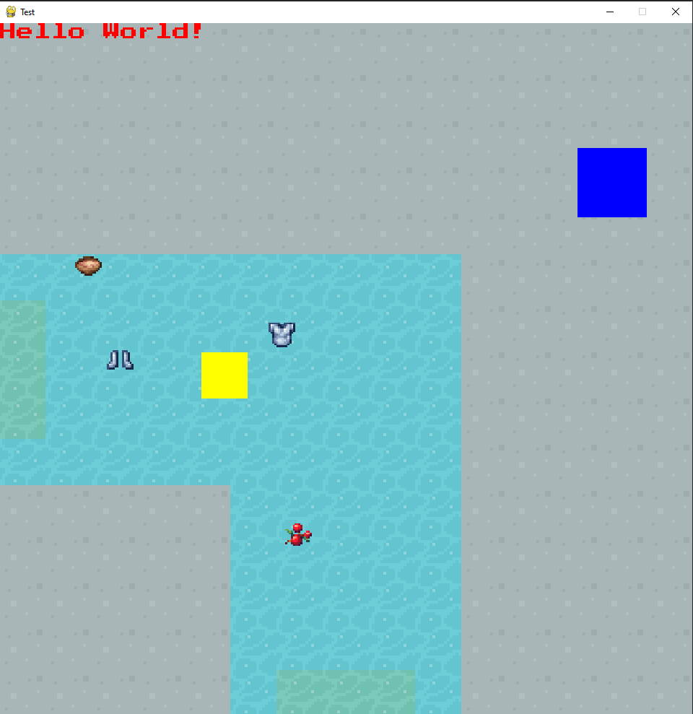

|  |  |  |  |
| --- | --- | --- | --- |
| Test | Expected Result | Actual Result | Pass or Fail |
| Display a paragraph of text | The text should all display on the screen | The text runs off the screen | Fail |

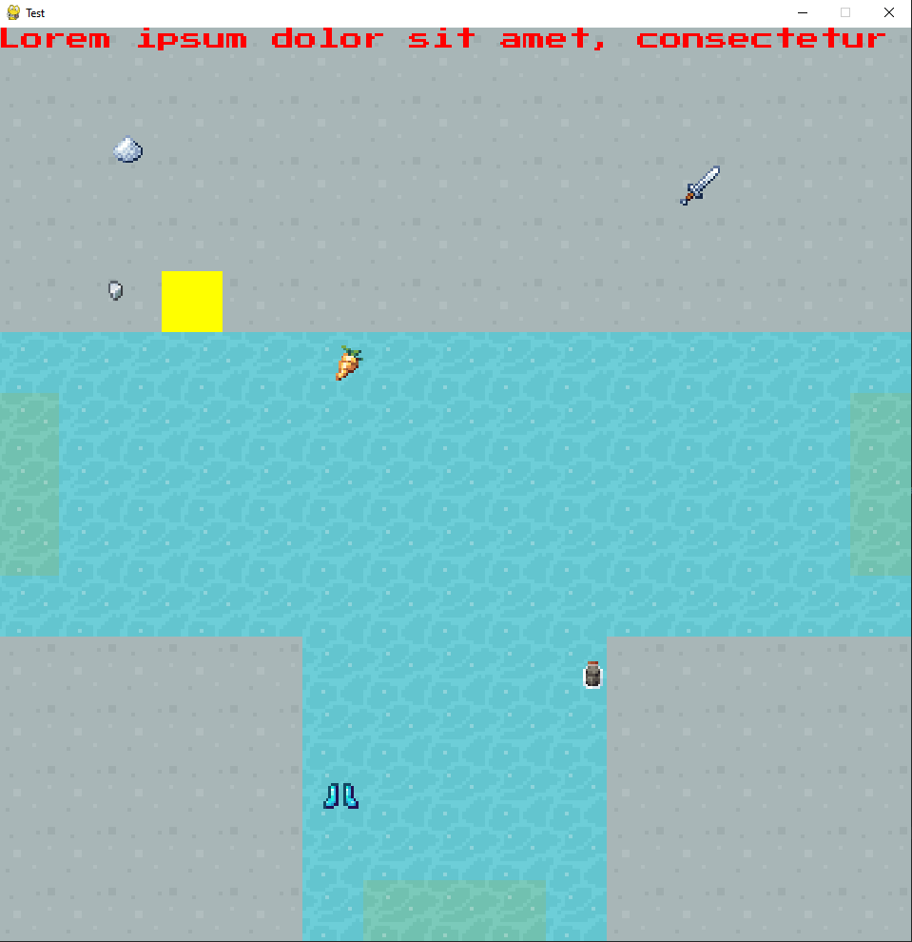

Pygame does not have any way of wrapping text so that it automatically goes onto a new line. I did some research for a good way to implement this and came across [this comment on the Pygame Reddit](https://www.reddit.com/r/pygame/comments/5j90g3/wrap_text_in_pygame/dbiv05p?utm_source=share&utm_medium=web2x&context=3). The user linked to 2 portions of code. I implemented them into my Box class:

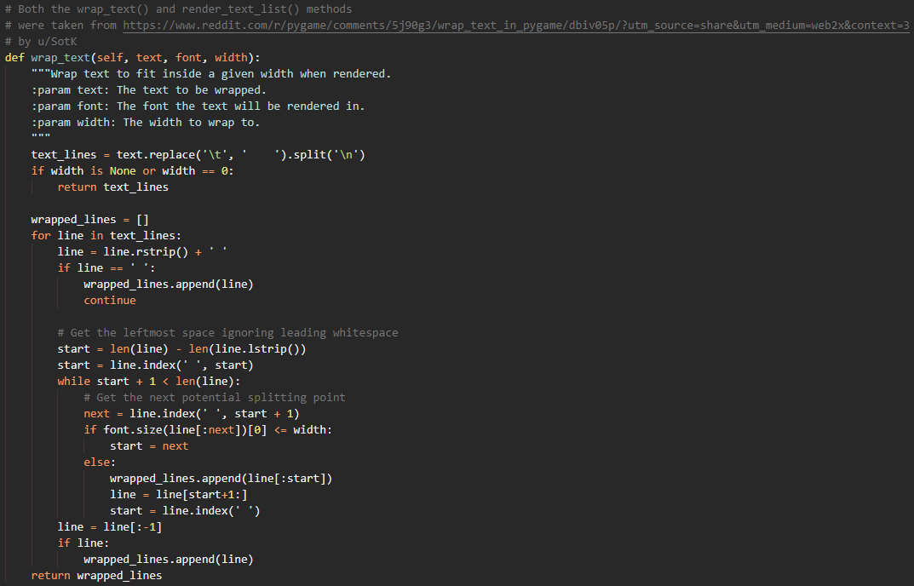

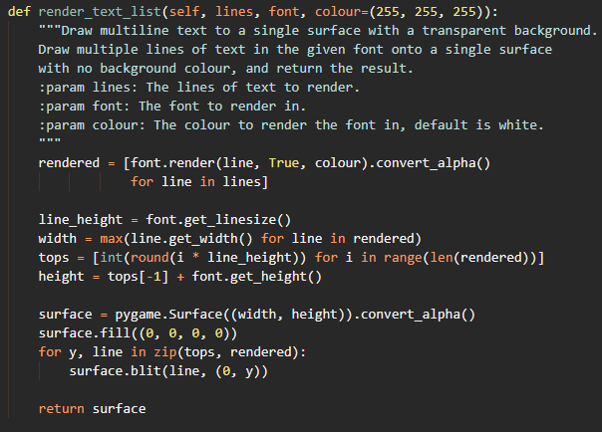

In order to get the text to display, I need to put the text through the wrap_text() method, then put the result of that method through the render_text_list() method. The result of this method will be stored as the image attribute of the class, which can be blitted to the surface:

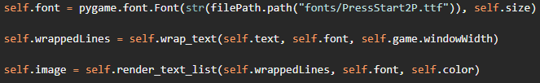

|  |  |  |  |
| --- | --- | --- | --- |
| Test | Expected Result | Actual Result | Pass or Fail |
| Display a paragraph of text | The text should all display on the screen | The text displays on the screen | Pass |

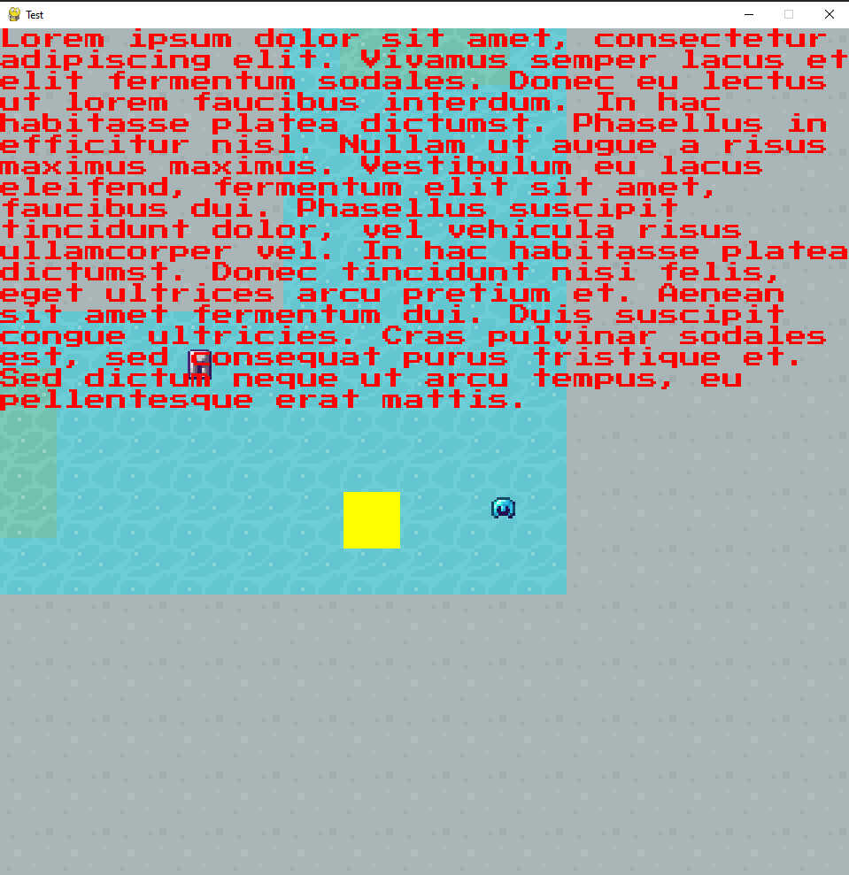

Finally, I need a way for the text to disappear after a given time. This best way to do this is by the use of the Pygame get_ticks() function. In Pygame, 1 tick is 1ms:

* When a Box object is instantiated, create a reference to the number of ticks at the point of instantiation
* Keep track of the current number of ticks
* If the number of ticks since the reference variable is >= a given time delay (current ticks – reference ticks)
* Given time has passed

In the Box constructor method, I can create a reference to the number of ticks:



In the main loop of the Game object, I can keep track of the current number of ticks:



Finally, I can make a method inside the Box class to determine whether a given number of ticks has passed:

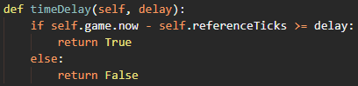

I will have a status text box to display most messages for the game. For now, I will instantiate the box object when the pause button is pressed, then wait 5 seconds (5000ms) before changing the text. When the “P” key is pressed, I will instantiate the box object:



Then in the updatePause method, I can check if it has been 5 seconds since the game was paused. If it has, I can make a new box object:



|  |  |  |  |
| --- | --- | --- | --- |
| Test | Expected Result | Actual Result | Pass or Fail |
| Pause the game | “The game is paused” should appear for 5 seconds, then switch to “It has been 5 seconds…” | “The game is paused” appears for 5 seconds, then switches to “It has been 5 seconds…” | Pass |

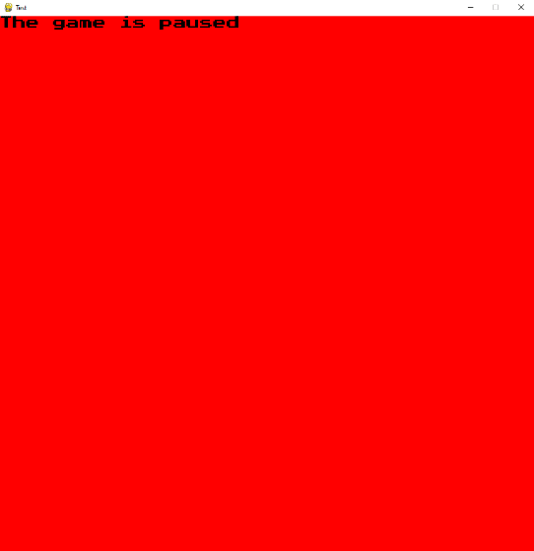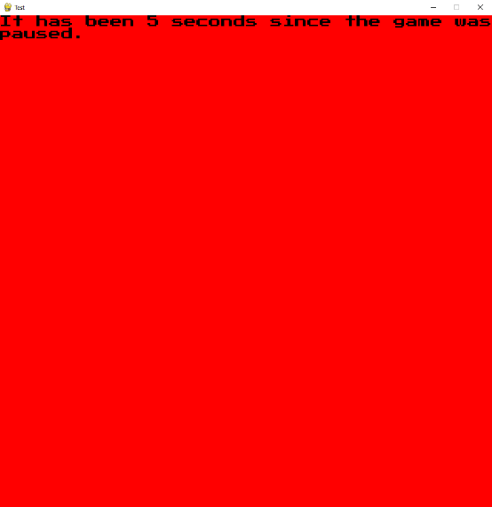

Implementing text boxes as a class makes adding text very easy. With relatively few lines of code, I can make the fight scene much more intuitive and informative:

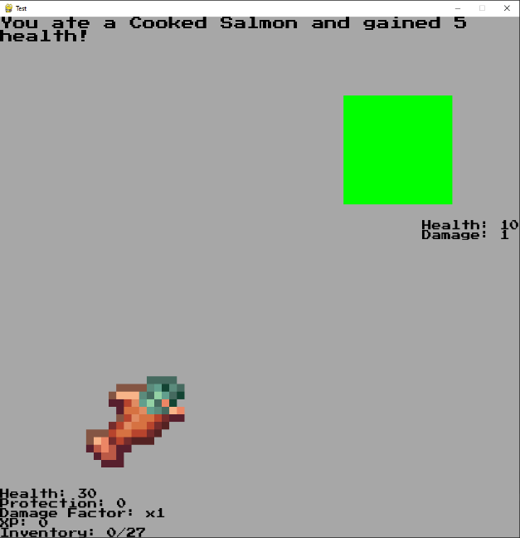

## ▮ Bosses

One of the last things I need to implement is bosses. Bosses will behave extremely similarly to enemies, so it makes sense for the Boss class to inherit the Enemy class. In my enemy.py folder:

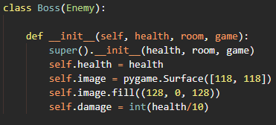

This will make bosses visibly larger than enemies, and a different colour. Their damage is also based on their health, which will increase with the floor that they are on.

Now, similarly to the way enemies are generated, I need to generate the bosses. I will create a generateBosses.py folder, and loop through all the rooms of all the floors of the dungeon:

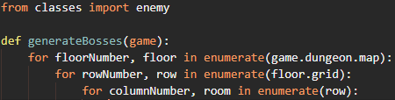

However, I would only like the enemies to generate in certain rooms; more specifically, rooms where there is a staircase down to the next floor:



And to make sure the player knows they are in a special room (and to make sure they are not overwhelmed), I will make sure there is only the boss in the room:

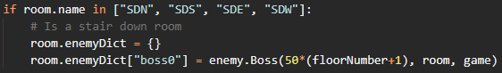

The boss’ health depends on the floor number that it is on, so the first-floor boss will have 50 health, the second-floor boss will have 100 health etc.

Finally, the player should not be able to advance to the next floor until the boss has been defeated. This means that the current room’s enemy dictionary should be empty:



|  |  |  |  |
| --- | --- | --- | --- |
| Test | Expected Result | Actual Result | Pass or Fail |
| Find the staircase down | There should be a boss in there, and in no other room | There is a boss in there, and in no other room | Pass |

|  |  |  |  |
| --- | --- | --- | --- |
| Test | Expected Result | Actual Result | Pass or Fail |
| Try and go to the floor below before killing the boss | Nothing happens | Nothing happens | Pass |

|  |  |  |  |
| --- | --- | --- | --- |
| Test | Expected Result | Actual Result | Pass or Fail |
| Kill the boss, then try to go down the stairs | The boss should die, disappear from the room, and the player should be able to go downstairs | The boss dies, disappears and can go downstairs | Pass |

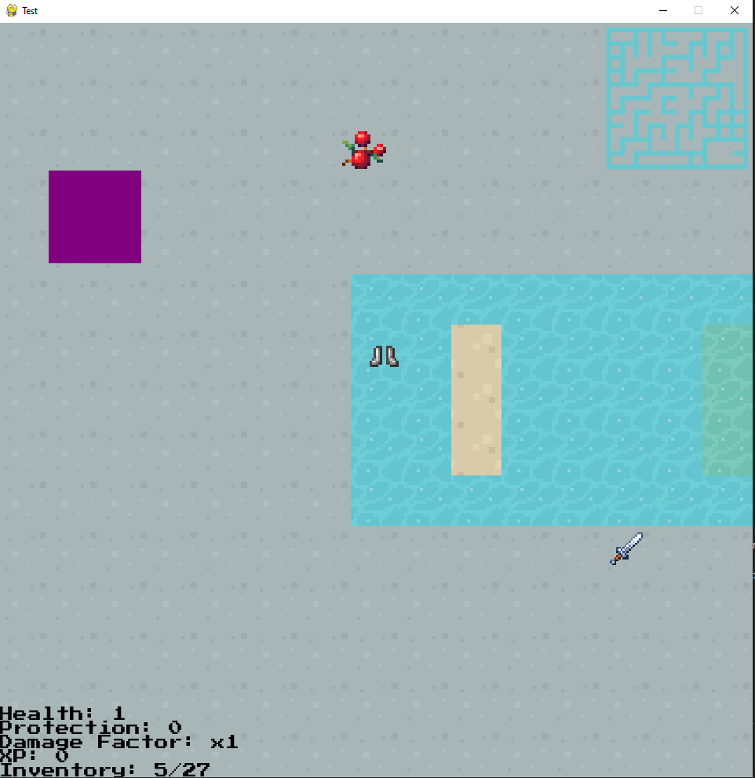

# Testing for Evaluation

## ▮ Self-testing

To put all aspects of my solution to the test, I played the game from start to finish. While this a mostly successful experience, there were a few issues:

* Clicking items that are in a pile (they are on top of one another) crashes the game
* The boss’s damage scales too quickly

Both issues are quite simple to fix.

When checking if an item has been clicked on, I create a list of every item that was clicked on:



The issue was, when clicking on a “pile” of items, this list had more than 1 item in it. I later iterate over this list and remove items from the itemDict of the room and place them in the player’s inventory. Changing the size and values of items in a list or dictionary that is being iterated over is generally a bad idea and is the reason the game crashes.

To fix this, instead of making a list of all items that were clicked on, I will just check if the current item was clicked on:



The second issue was that boss’s damage scales too quickly. The first boss’s damage is manageable, and maybe the second, but by the third boss the player is getting damaged for 15, which would kill them in 2 hits (if they did not have time to put some armour on).

To fix this, instead of making the boss’s damage 10% of its health, I will make the damage 5% of the health, plus 2.5:

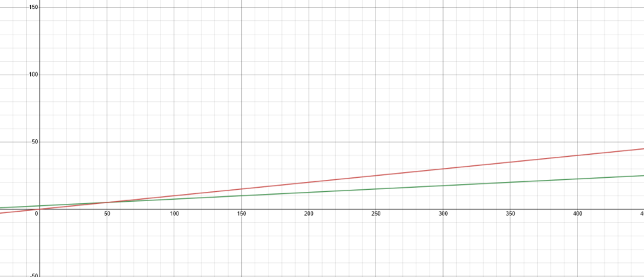

The red line is the old way of calculating damage (y = 0.1x) and the green is the new way (y = 0.05x + 2.5).

The green line has a small gradient, and so scales slower.

## ▮ External-testing

After fixing the issues I identified, I handed my game over to one of my friends to test and give me his feedback. He found no bugs, but was confused about a few things:

* It was not immediately obvious how to attack enemies
* It was not immediately obvious how to drop items

These issues had not crossed my mind as I had programmed these functionalities, so I always knew how to perform them in-game.

Again, these issues were simple to fix, I simply had to create some text to explain to the user how to attack enemies and drop items.

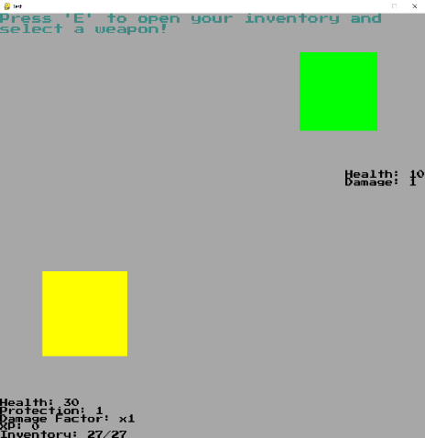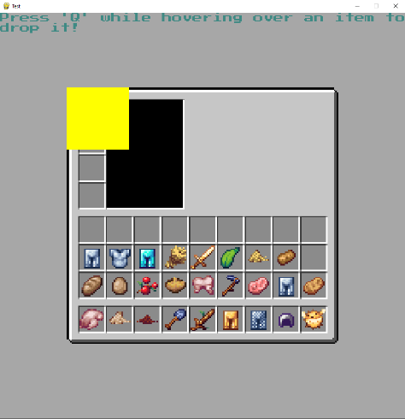

# Evaluation

## ▮ Success

### ▮ Menu

* Create a new save of the game

This criterion was partially satisfied; the player can create a new save of their inventory.

* Continue an existing save

This criterion was partially satisfied; the player can continue an existing save of their inventory.

* View current save files

This criterion was not satisfied; the player cannot view saves of the game or their inventory.

* Delete save files

This criterion was not satisfied; the player cannot delete saves of the game of their inventory.

* View and change any game settings

This criterion was not satisfied; game settings were not implemented.

Overall, the menu section of my solution was not implemented well. I did, however, implemented the groundworks for many of these points, so further development would be able to implement these criterions with little difficulty.

### ▮ AI/Computer controlled enemies / allies

* Physically interact with the player

This criterion was fully satisfied.

* Be able to die

This criterion was fully satisfied.

* Be able to kill the player (enemies)

This criterion was fully satisfied.

* Be able to help the player (allies)

This criterion was not satisfied; allies were not implemented.

Overall, the computer-controlled aspect of my solution was implemented very well. The only problem is that allies were not implemented. However, an ally would share many of the same behaviours as an enemy (movement, health etc.) and so implementing allies would be relatively easy by creating an ally class that inherits from enemy. (Or more accurately changing the enemy class to a “ComputerControlled” class, then having an enemy and ally class inherit the ComputerControlled class)

### ▮ Save game handler

To correctly save and load the game, the handler must:

* ~~Retrieve all variables from a JSON or CSV file~~
  + Retrieve all variables from a CSV or pickle file

This criterion was partially satisfied; my solution can retrieve some variables from a CSV or pickle file.

* Load all retrieved variables and values without corruption

This criterion was fully satisfied.

Overall, the data handler section of my solution was implemented well. My solution implements the basis for retrieving variables, and only needs to be expanded to all aspects of my game which should be feasible in further development.

### ▮ Gameplay

#### ▮ GUI

* Always display basic statistics in a clean, understandable way at the bottom of the window

This criterion was fully satisfied; statistics are always displayed in an understandable way

Overall, this section of my solution was implemented very well. All aspects of my GUI (including the statistics) are represented in a clean understandable fashion to prevent confusing the user.

#### ▮ Pre-game

* Display several planets in a friendly way

This criterion was partially satisfied; planets can sometimes overlap

* When a planet is clicked on, show its details including its name and its climate

This criterion was partially satisfied; clicking on a planet does show its name, but climate was not implemented.

* Allow the player to select a planet when they have found one, they like

This criterion was fully satisfied.

* Choose character appearance

This criterion was not satisfied; the player cannot choose their appearance (as I did not implement graphics),

Overall, the pre-game section of my solution was implemented well. The only aspect missing is each planet’s climate which would be easy to implement in further development.

#### ▮ In-game

* Allow the player to freely move around a fixed room and enter new rooms

This criterion was fully satisfied.

* Allow the player to interact with the AI enemies and allies

This criterion was fully satisfied.

* Allow the player to advance to a different floor

This criterion was fully satisfied.

* Be influenced by the planet’s climate

This criterion was not satisfied; the dungeon is not influenced by the planet’s climate (since the planet has no climate).

Overall, the in-game section of my solution was implemented very well. Had the planets had a climate, making the dungeon reflect that climate would be a matter of graphic designing dungeon rooms with different colours etc., then choosing the right files depending on the climate.

## ▮ Maintenance

This project is quite easy to maintain. Most of the code is dynamic, meaning it will work even if other aspects of the code change. There are, however, a few hard-coded aspects which would need to be changed if the project were to be maintained well. Making use of classes for much of my code also helps maintenance, allowing me to change the attribute of the class and have all the objects reflect that change, rather than changing variables individually.

## ▮ Further development

Quite a lot of features in my solution would benefit from further development (as I have outlined in my success section).

Firstly, graphics would bring a huge difference to my solution. This would range from the dungeon being influenced by the planet’s climate and the user being able to choose the player’s appearance, to enemies having visual sprites. All of these would improve the immersion of my game (and thus provide that escape from the stresses of reality). Implementing these graphics (once they have been created by a graphic designer) would be relatively straight-forward, as I have referenced external files in all my code, so simply updating the file path would be effective.

Next, being able to save and load the entire game, rather than just your inventory, would make the game more “pick up and play”. Again, I have coded the basis for this concept. All the further development team would need to do is extend my logic to all aspects of the game (such as the dungeon object, player object etc.)

Finally, being able to view, edit and delete existing saves would allow the multiple users to use the game. This would allow users to share the game with their friends, without them having to download and install the game. This would expand the player-base.